GLENBROOK POINTS
Newsletter of Glenbrook & District Historical Society Inc.
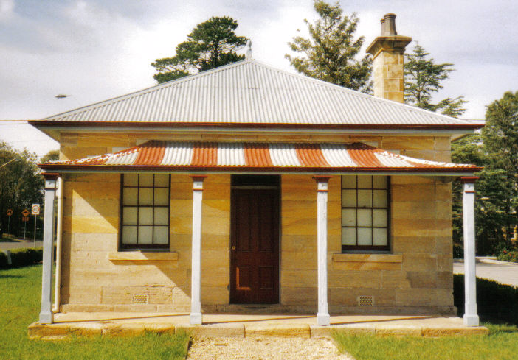
POINTSMAN'S COTTAGE
AUG-SEPT '18
Postal address P.O. Box 38 Glenbrook NSW 2773
Contacts: President Joan Peard 0414 605 482 or Secretary Neil McGlashan 4739 9864
EDITOR W.(Bill) Peard …. E-mail:- jpe13704@gmail.com
E-mail:- gdhs@gmail.com Facebook:- Glenbrook & District Historical Society Inc
Meetings 3rd Wednesday monthly at 1.30 pm (except Dec-Jan) Glenbrook Guides Hall
cnr Hare & Moore Sts. Glenbrook

"HISTORY WALKS" PROGRAMME for 2018.
All on Saturdays: Walks led by Doug. Knowles & Team.

Sept. 1st: 9.00am “Eastern Zig Zag Railway 1867” and the first improvement: The Lapstone Hill Tunnel route. 1892
Sept. 29th: 9.00am “Glenbrook Heritage Walk.” Historic sites, houses and West Portal of Lapstone Hill Tunnel--1892. ( Last Walk for the year.)
BOOKINGS are ESSENTIAL: Phone Doug on 4751 3275. Please allow the phone to ring longer than usual for details re meeting place, time and grade of walk. Good walking shoes are essential. Please bring a hat and drinking water. (No dogs please.) BAD WEATHER ON THE DAY: Excessive wind or rain could cause cancellation due to hazardous conditions. Adults: $10 (Except for Special Walk.) Accompanied Children under 16yrs. Free
ERROR: June/July article “St.Finbars Church 1912” by Patricia Murnane..”Blaxland, Lawson & Wentwoth camped nearby” should read “PASSED NEARBY”. Refer to Newsletter Feb/March 2015 article BRIEF HISTORY GLENBROOK.

ST. ANDREW’S UNITING CHURCH
GLENBROOK, BRIEF HISTORY (by Peter Berry)
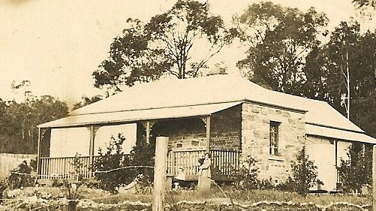
The origins of Glenbrook Uniting Church church go back as far as the early 1880s when, through research carried out by the late Ken Pickering, the Nepean Times in 1883 reported that the Presbyterian minister from Penrith/St Marys, the Rev Clausen used to come up to the tiny village of Glenbrook once a month on Friday evenings in his horse and buggy to visit a few Presbyterian families in the village.
A little Presbyterian congregation formed over the following years and first formally met as such during an evening service in the village in 1927 with about a dozen people present. The services were held in the King Street homes of Mrs Gibb and Mr W.H.& Mrs Williams. Both homes still exist today.
Mr W.H.& Mrs Williams home "Wyuna" King St
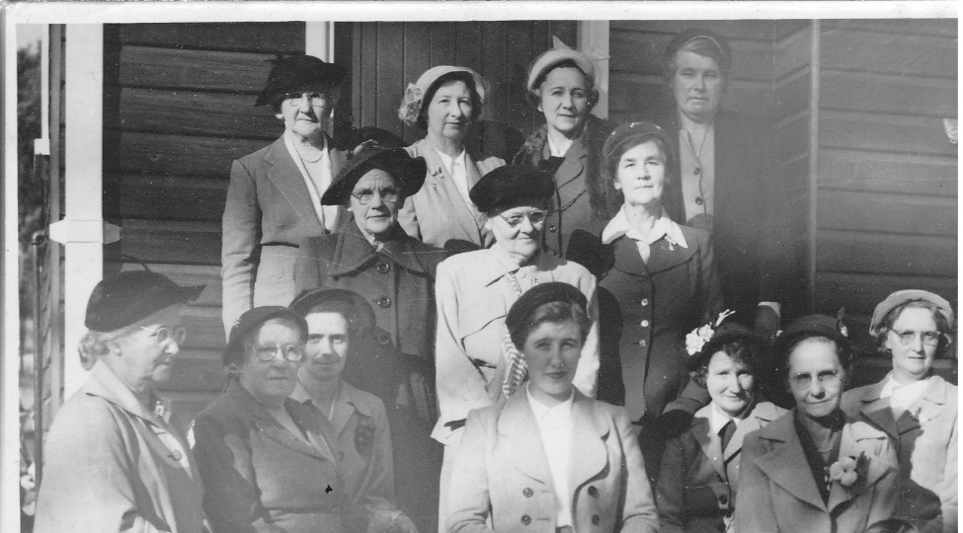
Other people there at the beginning were George and Jessie Bunyan who were pioneers of Glenbrook and whose daughter, Joan Peard, remains connected to the church to today. Services were held in private homes for some years but later the Glenbrook School of Arts was used for weekly worship. The Glenbrook congregation was then part of the Springwood Presbyterian parish. In 1951 a Women’s Guild was formed and set about raising money to buy a block of land. Key women involved were as photograph left-right-► Top row. 1.Mrs Burfield 2.Mrs Bunyan 4.Mrs Pickering. Middle row 1.Mrs Lovett Front row 1.Mrs.Williams 3,MissV.Fisher 5.Mrs.Clague 6.Mrs.Cartwright The ladies raised the necessary funds to purchase the block of land on the corner of Lucasville Road and Green Street and a church was subsequently built by voluntary labour at a cost of £750 ($1500). Names of all the volunteers were buried in a bottle under the church which, as far as is known, remains there today. The church was formally opened on a cold Saturday afternoon on 12 June 1954.
St.Andrews Womens Guild 1954

Margaret Elizabeth Williams was the first child baptised when the congregation met in the King Street home of Mrs Gibb. The same Margaret Elizabeth Williams was the first person married in the newly built Lucasville Road church.
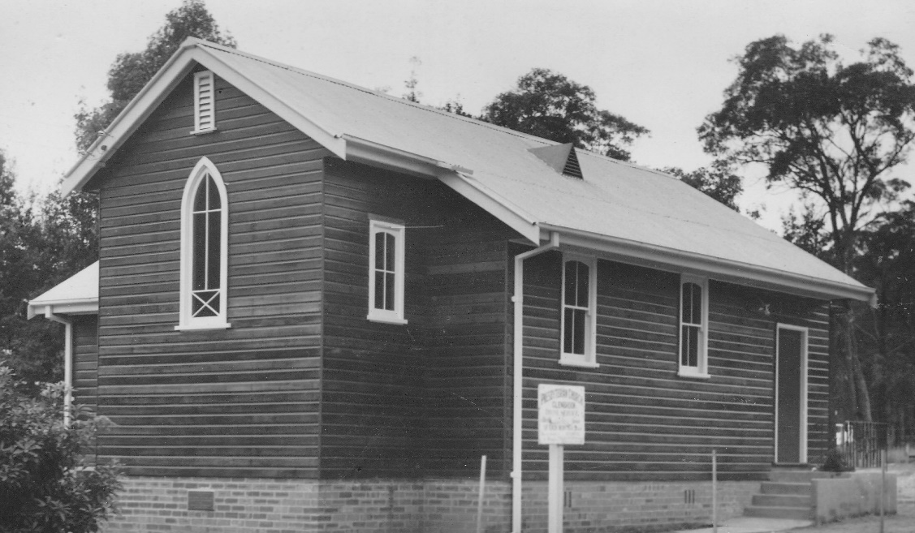
The church was later added to and improved several times and a hall built with major extensions being carried out in 1979. For a long while Glenbrook and Blaxland was a joint Presbyterian parish but when the Uniting Church came into being in 1977, Blaxland remained Presbyterian and Glenbrook became part of the new Uniting Church. Glenbrook was the only Presbyterian Church between Penrith and Lithgow to become part of the Uniting Church. Since the beginning of the Uniting Church, there have been 6 permanent ministers. – Rev. Michiel Groenewegen, Rev. Keith Esterbrook, Rev. Neil Smith, Rev. Elizabeth Orr, Rev. Susan Phalen and from April 2018 Rev Ellie Elia.
St. Andrews Church 1954

The pews were made by Alec Dunn (Builder) and donations by Mr & Mrs Pickering (Organ), Mr & Mrs Clague (Hymnal board), Mr & Mrs G. Bunyan (Communion Table in memory of daughter Jessie), Mr Alec Dunn (Pulpit in memory of his parents Mr & Mrs J.C.Dunn), Mr & Mrs W.H.Williams (Baptismal Font in memory of son Eric), P.W.A. ( Carpet and Runners)
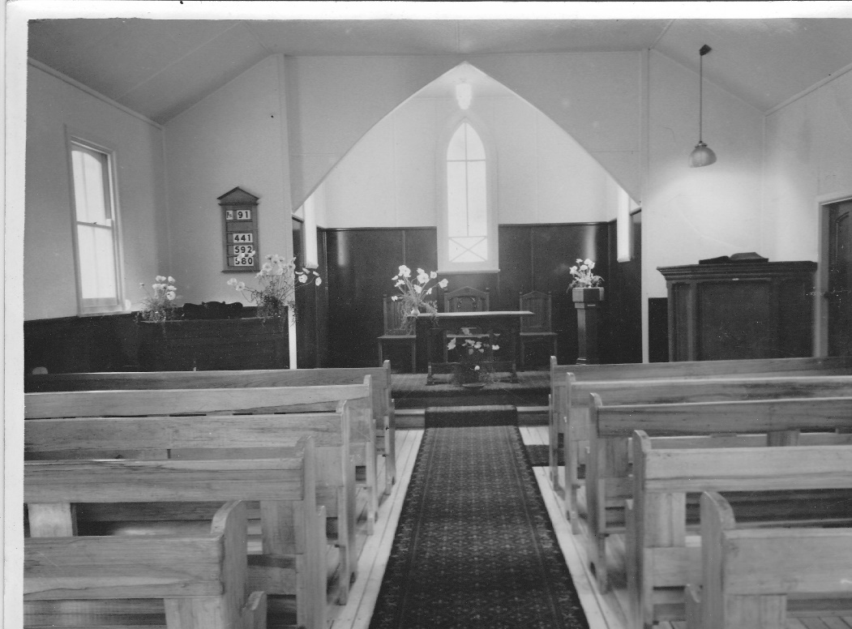
St.Andrews Church Glenbrook 1954

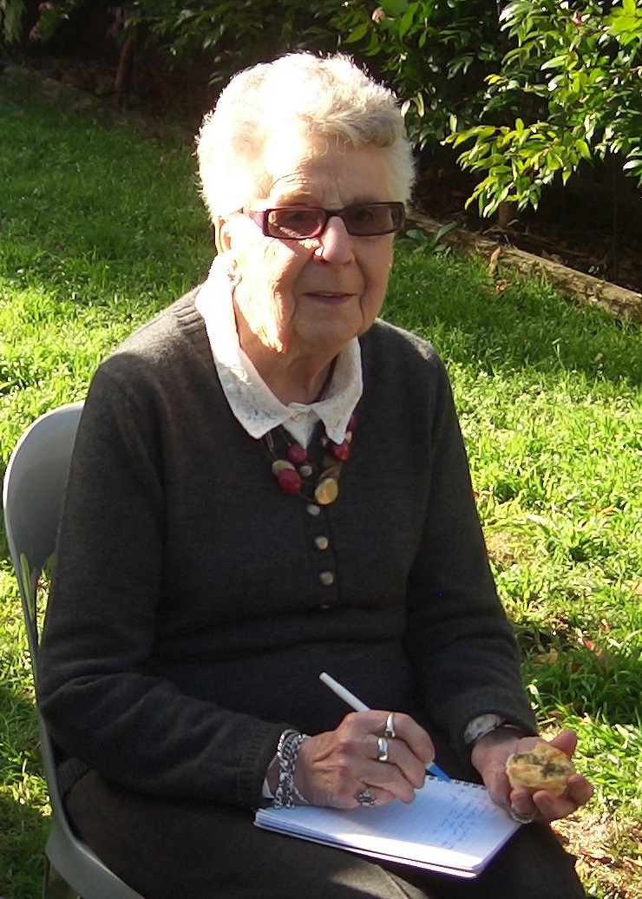
PAM’S PAGE
RED HAND CAVES
For many thousands of years the Durach people lived in and roamed in these Blue Mountains and proof of history remains in the “Red hand cave”, which is in the National Park in Glenbrook. An article appeared in the Nepean Times in 1933 with the following story, “Four miles South West of Glenbrook is the site of the Red Hand Cave. The few authorities on Aboriginal Lore, who have seen the cave, say it is the most striking example of it’s kind in Australia”. Few people know of it’s existence and fewer could find their way there.
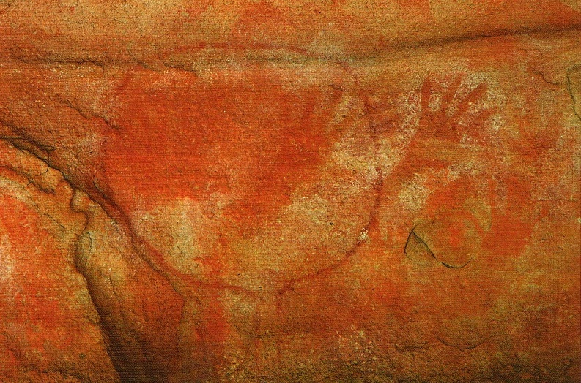
The cave was found by accident in August 1913 and an inscription on the cave wall, found and photographed by amateur archaeologist Clifton Towle 1933, read “Jim Dunn 10 August 1913”, James (Jim) Colquhoun Dunn, a Glenbrook builder, with George Ernest Bunyan, an Emu Plains butcher & bushman, together with a party of local railway workers, in August 1913 were searching for a young (21yrs) Glenbrook girl, Ruby Hunter. She was a cousin of Jim Dunn. Ruby left her Glenbrook home, together with her two dogs, to collect flowers in the bush and became hopelessly lost. Ruby was found safe, near Glenbrook Creek and closer to Blaxland, It is believed that during this search Jim Dunn made the inscription on the wall.
George E.Bunyan guided Mr W.Thorpe Ethnologist & Mr C Clutton Photographer from the Sydney Museum to the site on 17th March 1924. They were met by Messrs T.Cornell, J.Dunn, G.K.Bunyan, A.Gates (Nepean Times) and all were amazed at the hand prints, The method of hand painting was to grind into powder a piece of red sandstone and mix this with water. Taking a mouthful, the Aboriginal blew in a fine stream all around the outline of their hands. Another of the markings is a rough circle with the hand prints inside the circle and is thought to be the equivilant of a visitors book where travellers from other areas would leave their mark.
Red Hand Cave
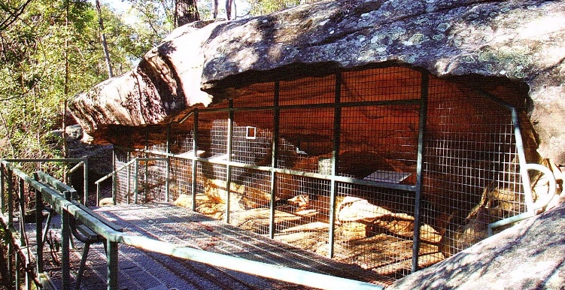
Unfortunately as the popularity of the National Park grew, more visitors came to visit the cave and it was slowly becoming defaced. To stop this awful practice continuing, there is now a grill covering the front of the cave to protect this very interesting part of Daruch history for generations to come.
Viewing Platform Red Hand Cave

ILFORD HOUSE 1884-1984
Courtesy Blue Mts. Collection Faulconbridge

A gothic styled picket fence and gable roofed lych-gate form a most inviting entrance to the whitewashed stone cottage nestled amongst a myriad of flowering shrubs and maturing pines. Known as “Ilford House”, this semi-secluded cottage has observed the comings and goings of many a distant traveller since the mid 1880’s, but has remained fairly inconspicuous itself. Little was known about the house when purchased by it’s present owners in 1984, being described by them then as a house of mystery.

