GLENBROOK POINTS
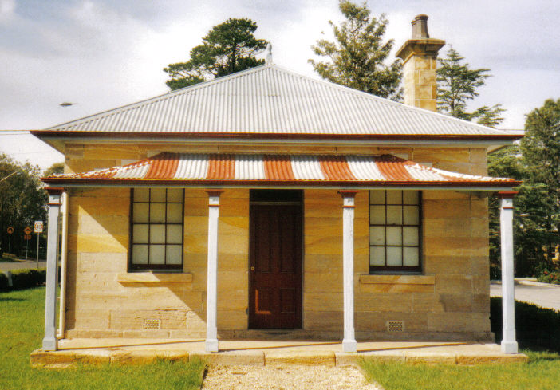
Newsletter of Glenbrook & District Historical Society Inc.

APRIL – MAY 2019
Postal address P.O. Box 38 Glenbrook NSW 2773
Contacts: President: Denis Bainbridge Secretary: Neil McGlashan 4739 9864
EDITOR W.(Bill) Peard …. E-mail:- jpe13704@gmail.com
E-mail:- gdhs@gmail.com Facebook:- Glenbrook & District Historical Society Inc
Meetings 3rd Wednesday monthly at 1.30 pm (except Dec-Jan) Glenbrook Guides Hall
cnr Hare & Moore Sts. Glenbrook
"HISTORY WALKS" PROGRAMME for 2019.
All on Saturdays: Walks led by Doug. Knowles & Team.
March 9th 9.00am “Lennox Bridge” and the old stone quarry, Brookside Creek,
Dunn’s Steam Saw Mill relics, and earth dam.
30th 9.00am “The Descent to the West:” Mt.York : Three short return walks on the three most historic roads to the West: Cox’s Pass 1815. Lawsons Road 1822 and newest: Berghofer’s Pass 1909.
Includes Tea/coffee, biscuits. Special Walk: 12.00 .
April 13th 9.00am “Eastern Zig Zag Railway” This walk on the 1867 Zig Zag Railway.& Knapsack Viaduct, also extends to the first improvement, the Lapstone Hill Tunnel 1892. [East Portal only,] and the wash-away section 1906.
May 11th 9.00am “Eastern Zig Zag Railway.” This walk is focussed on the Knapsack Gully stone viaduct and offers good photograph opportunities. Includes Gatehouse No. 1, 1867 and the Knapsack refuge sidings 1909.
June 8th 1.30pm “Duck Hole--Glenbrook Creek.” Old roadway construction and pump site for railway water supply to old Glenbrook Station.
29th 1.30pm “The Mountains Murders.” Captain Lee Weller’s grave site and rock inscriptions.
July 13th 9.00am “Faulconbridge Steam Sawmill Site.” Engine remnants and other relics. Operated 1914-1925..
Aug. 10th 9.00am “Bull’s Creek.” Railway relics:- Stone dam and steam pump relics.
31st 1.30pm “Lapstone Construction Railway.” 1910-1913 and east portal of Lapstone Hill Tunnel 1892..)
Sept. 7th 9.00am “Glenbrook Lagoon Precinct.” Early campsite and railway dam
construction 1880 for water supply to the first Glenbrook Station.
28th 9.00am “Glenbrook Heritage Walk.” Historic sites, houses and West
Portal of Lapstone Hill Tunnel--1892.(Last Walk for the year.)
Adults: $10 (Except for Special Walk.) Accompanied Children under 16yrs. Free BOOKINGS are ESSENTIAL: Phone Doug on 4751 3275. Please allow the phone to ring longer than usual, for details re meeting place, time and grade of walk. Good walking shoes are essential. Please bring a hat and drinking water. (No dogs please.) BAD WEATHER ON THE DAY: Excessive wind or rain could cause cancellation due to hazardous conditions.
Herwald Gordon Kirkpatrick

EDITOR:- This is an abridged version of H.G.Kirkpatrick’s story, the original can been accessed at the Society’s museum- Document folder 9, Page 1. The museum also possesses the guest book, with signatures of all present, to the United Nations conference 1948. Photos G&DHS collection.

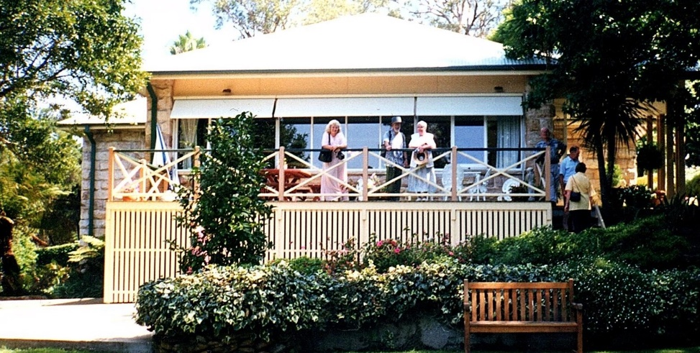
Herwald.G.Kirkpatrick is best known in the Glenbrook area as the owner and builder of the Lapstone Hill Hotel, 1928, and which was sold to the R.A.A.F. in 1949. But little has been published locally on his previous life. Herwald was born in Sydney 23rd August 1891 and died in London UK 26th September 1951. He was the 3rd child of John and Anne Kirkpatrick, descendants of Kirkpatrick Clan of Closeburne Scotland.
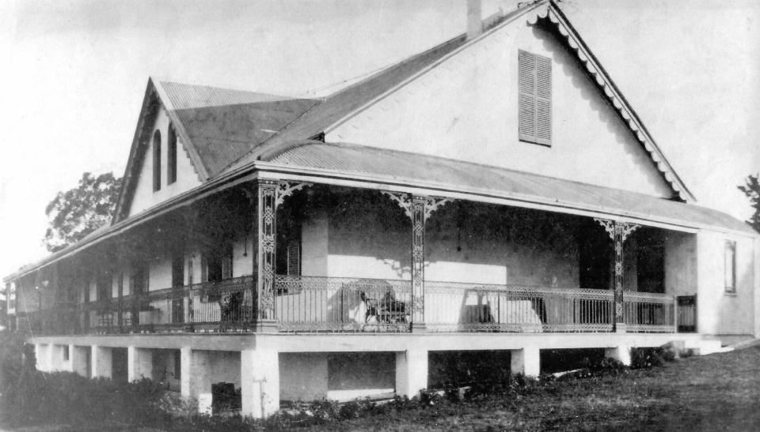
Herwald married twice (in Australia) 1920 to Oriel Wilson, with two children Lolita 1921 & Naomi 1923 (now both deceased). Divorced 1940 and remarried 1941 to Mavis Harris with one child, Ivone 1949. His married life may have been odd for that era, but he was a very entrepreneurial businessman. He was a qualified Architect & Consulting Engineer ( Mechanical) with a long list of successful activities, the idea in 1921 of a Hotel on Lapstone Hill being just one of them.
Briarcliffe Glenbrook c2000
1914-1919, The firm of J & H.G. Kirkpatrick were commissioned to design and manage the construction of the Head Office for the Commonwealth Bank of Aust. in Martin Place, opened in 1919. They then built bank buildings in Melbourne, Newcastle, Geelong, Nth Sydney, Cairns and Shepparton. In 1918 the same firm was appointed designer & project manager of contract homes under “War Service Homes” project, which finished 1921. A total of 1,777 homes were built in all States.
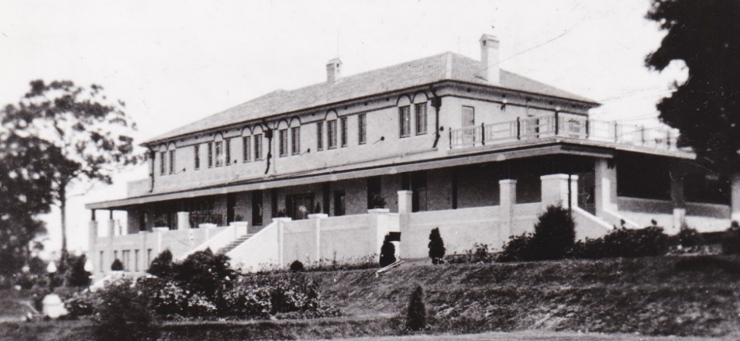
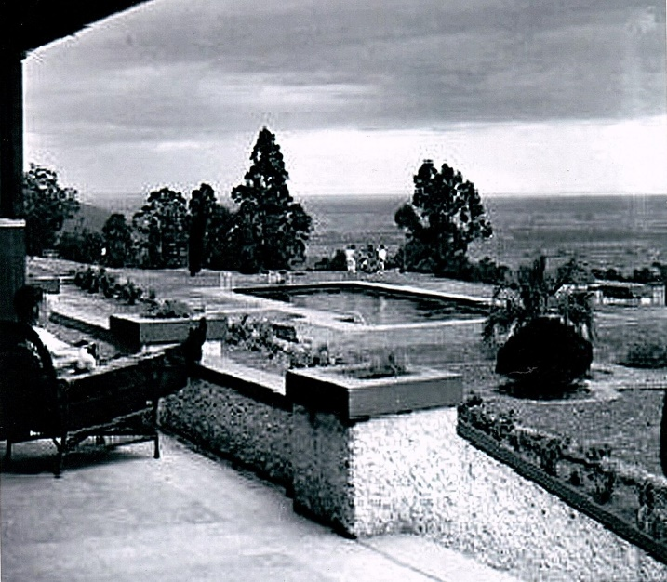
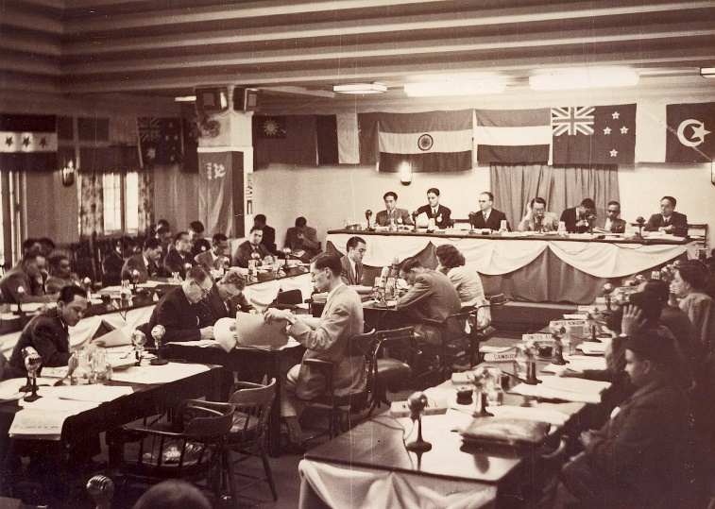
1921 saw the beginning of another project, Herwald, George Herbert and Douglas Morris, purchased the Lapstone Hotel Hill site from Colin Smith. Colin had inherited the property from his father Capt. Charles Smith of Howard Smith Ltd., in 1897. They intended to subdivide and develop the property for their private use. Douglas commissioned John C. Dunn and his son James to build “Briarcliffe” on his part of the property and Herwald retained the existing home on the site, “Logie”, which has been built in 1878 by Mr John Lucas. Herwald realised that with the spectacular views over the lower Hawkesbury, the site would be ideal for a hotel and he registered a public company known as “Lapstone Inn Ltd” for which he was Managing Director. Construction of the Hotel commence in 1928, being built over the existing “Logie”. The hotel commenced operation in January 1930 being well received, 57 modern rooms, grand ballroom, bar room , sweeping gardens, tennis courts, bowling green, majestic swimming pool and golf course.
Lapstone Hotel built on “Logie” Site
John Lucas Residence “Logie” c
1948 United Nations Conference Grand Ballroom Lapstone Hotel
Lapstone Hill Hotel 1948
were superior to the hotels in which he had stayed in Lucerne, Switzerland. The hotel was popular with charity balls , business and political conventions and stayovers for medicinal reasons because of it’s altitude. Hard times in the Great Depression caused “Lapstone Inn Ltd” to go into liquidation and title was transferred to “Lapstone Hill Ltd” In February 1945 the hotel was host to the “United Nations Relief & Rehabilitation Conference”, 85 representatives from 9 Nations. This was followed up in November 1948 as host to the “United Nations Economic Commission for Asia & Far East Conference”.
Located about 64K from Sydney it advertised that a car was despatched to meet every train at Glenbrook station to transport guests from station to hotel and return. With the onset of WWII 1939 patronage for the hotel fell away and in 1949 the Federal Government purchased the hotel on behalf of the R.A.A.F.
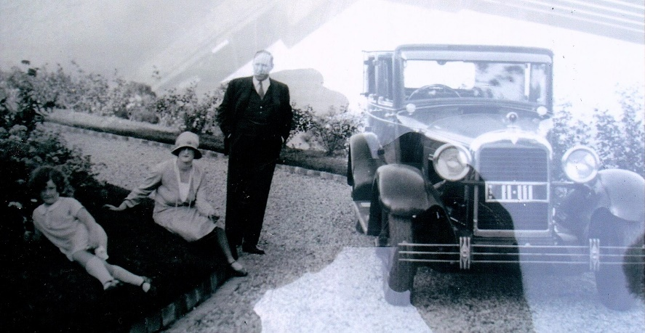
Herwald was always interested in mechanical engineering and motor vehicles. The number plate to his Morris vehicle was “11.111” During the mid 1940’s he succeeded and fitted his first motor vehicle, his Morris, with a mechanical changing gearbox. Friends and relatives remember being transported along William St to the top of Kings Cross, Sydney, without the use of a manual operated clutch. He applied for international patents in 1946 and these were registered in USA, UK, and Europe, then he was issued with Letters of Introduction in 1948 (Ben Chifley) and 1950 (Robert Menzies) travelling to UK and Europe. During the second promotional trip to UK, via USA, he took seriously ill and was admitted to South Battersea Hospital where he died of cancer on 26th September 1951. The patents expired 10 years after filing, viz 1956, his widow, Mavis, was financially unable to keep patents live. The patents were taken over by the same motor vehicle companies to whom he had earlier promoted his design. He received no acknowledgement or recognition with regard to his achievement, which was the start of a revolution within the motor industry. He may have been aware of his illness and had proposed that Standard Cars should carry on with the promotion of the automatic gearbox in the event of his death.
Herwald, Oriel & Naomi, Lapstone Hotel c1940’s
GLENBROOK’S PRIVATE SCHOOL
Looking Back by Ralph Calver 1993

In the early 20’s I attended a private school located on the eastern slopes in an area adjacent to the R.A.A.F. Base – formerly Lapstone Hotel. It was housed in an elegant 19th century sandstone block building with slate roof and built in attic. The original sweeping view of the Nepean River and the plains is now obscured by dwellings erected since my days as a primary school student. I was one of six day boys and about 12 boarders.
The principal, previously on the staff of another school on the Mountains, opened the college as a profit making venture in his own right. From memory I recall him as being in his 30’s, alert, quick witted and not overweight, but of muscular build, in some ways like a boxer. His wife and young daughter lived on the premises, also a youg lady taught French.
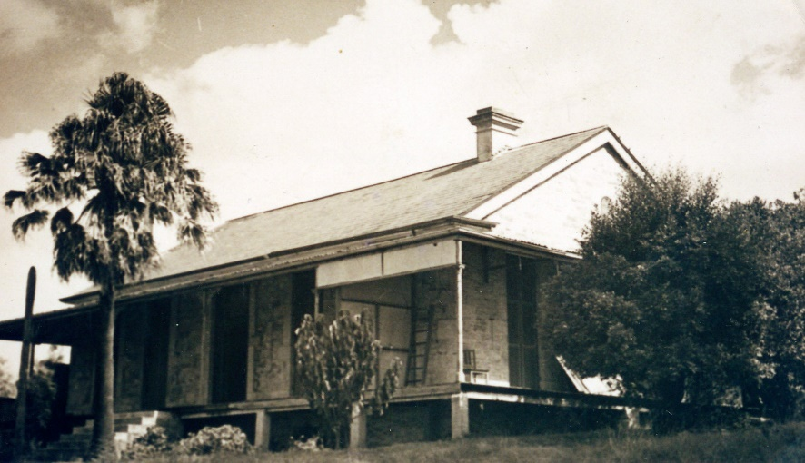
School activities included physical culture, boxing and rowing, in hired dinghies, on the Nepean River We picnicked on the grassy banks. There was something sadistic about “Sir”, as we called our principal. At picnic lunch time, boarders were invited to sit beside a bull ant’s nest and join in a competition. He who stayed the longest would receive double pocket money. Contestants took a bundle of sticks with them. When the ants crawled onto the stick it would be flicked away. The bull ants were savage and aggressive.
"Ulinbawn" Glenbrook c1950
In school hours “Sir” was very handy with the stick. He did not buy canes. Boarders were required to go into the scrub and collect thin saplings from native trees which were put into good use. Spelling and arithmetic tests were frequent and every mistake in excess of two carried a penalty of two – max six. During my relative short period as a private school pupil, educational standards were maintained stimulated by the threat of the stick wielding headmaster.
It was a healthy life, most days my brother and I walked in from Blaxland, nearly three miles (5K) away. The outdoor activities and physical exercises enhanced our wellbeing. The few knocks I received at boxing did me no harm. After four terms of attendance, my private school education came to an abrupt halt. The desks, forms, books, maps, inkwells, sticks and other accessories were gone. Only the building remained – empty. There were a series of events which preceded the hasty closure.
The boarders had made a large cubby house in the bushland adjacent to the school, a secret retreat where they had privacy, away from the school building. One weekend “Sir” picked his way through the scrub to investigate. He was apparently horrified and incensed by what he saw. My brother & I arrived at school on Monday morning, there was an uneasy silence. Normal exuberant school boy talk was reduced to hushed undertones. The headmaster had a dozen or more caning sticks on his desk. Boarders were assembled in the classroom and ordered to remove their trousers. Each was required to bend over a desk and receive a frenzied thrashing. As each stick shattered it was thrown out the door. Multiple weals on bare behinds told their own story. Alleged ring leader of the cubby house’s questionable behaviour was tall and well built. He was not caned but expelled.
One of the students was away, due to return in a week. He did not know what was in store for him. Fellow students waited eagerly
to collectively view him pantless. receive the treatment they had received. He was a quiet reserved youth with an air of dignity. When the caning started he pulled up his pants and snapped: “cut that out . Sir”. “Sir” was taken aback. He stopped, threw the cane away, this was the collapse of the Collegiate School Glenbrook.
Not long after, we arrived at school to find “Sir” bruised and battered. Explanation was that he had walked from Emu Plains after dark and fallen over a railway cutting. We found it hard to believe that our principal would choose to clamber up the untracked mountain side when railway travel was available. It was reported that there had been a violent argument with the local storekeeper over unpaid bills. Son of the landlord was never caned, maybe the rent was in arrears. This was the end of private school education for me. I enrolled in the newly opened school at Blaxland. The “school” building is now a private residence.

EDITOR: Donald Skarratt Junior in 1977 wrote “The first private school in Glenbrook was conducted by Mrs Durham in Shallard’s Cottage …. and I can only remember three pupils other than myself, one was Joan McGinlay, Roma Durham (daughter) and Phillip Steel.
Apparently Mr Garnet Swift Durham had great ambitions, he ended up at “Ulinbawn” as the headmaster (and owner) of the Glenbrook Collegiate School. The school was operational from 22nd September 1924.
Some of the pupils I can remember, Robert Peter Rutherford, John Bush, Allen Milburn, Henry Joyce (the biscuit making people) and Archie O’Neill.” He also wrote “My father (Donald Skarratt Senior) was in residence in Ulinbawn in 1906.”
The reference to Shallard’s Cottage would be to Major Shallard’s residence of late 1880’s. He was instrumental in forming the first Glenbrook Public School. He had long left Glenbrook but the cottage held his name.


From The Secretary’s Desk
RAAF 1941 Plaque Clifton Avenue: - Denis – with the proposed plaque on the wall at Glenbrook Bowling Club. I have received a quote from Plaques.com.au. We have the approval of the Blaxland-Glenbrook RSL sub-Branch. Will look at applying for a grant from Department of Veterans Affairs. Will try and have ready for next ANZAC Day.
Pioneer Wall Family Plaques: Doug – With the restoring the plaques. It is superior in every respect to the old wall and all the original plaques are all put back in their exact same positions they had on the old wall. With future plaques which are postcard size 140mm x 110mm made from stainless steel will cost the family $175 incl. GST with an Application form. 9 positions left on the highest wall. 24 more on the lower wall. Let us know of people who you know whose families came to Glenbrook before 1950 and may want to participate.
Air Crash Plaque for Glenbrook War Memorial: Denis – Neil received in the mail this morning from Stuart Ayres that his representation for a State Government grant had been successful for $885 for a new plaque to go on the wall at the bowling club for the 1941 plane crash. A copy of the plaque is being passed around for members to see.
Betty Asser: Display at the Museum her wedding dress. 67 years old and in perfect condition.

There is a picture of the wedding and the dress in this issue of the Nepean Times. It is not a long dress. Moved: Doug / Seconded: Kevin that we say yes and get a mannequin to put the dress on display with the Nepean Times article.
Gay Hendriksen Museum Advisor 26 January 2019: The year will start with a Museum Meet on March 5th at the Cultural Centre. We will look at what is happening over the year and have a catch up and information share. What do you have planned for the year, what things do you need help with, how can we help on projects etc. There are two planned workshops

Did You Know??? Some Trivia
(1) A report in ‘Australian Town & Country Journal’ on 18th Feb 1893 reports “The beautiful part of the Blue Mountains may really be said to begin at Glenbrook. A place comparatively little known to the travelling public, this is the starting place of the Zig Zag & the scene of the great Lapstone tunnel. Here the traveller can find all the comforts in the establishments of Mrs S. & Mrs D Hamment”…. “further up the mountains comes the picturesque little village of Wascoe, here may be seen an old convict stockade ”
(2) In the great rail washaway at Glenbrook 1906 it was reported in the Nepean Times, that Mr D Skarratt Snr stopped the upcoming train. His son, Donald Junior, in 1977 reports “The sight they saw was pretty terrifying, a train was coming”. His brother Thomas and a servant girl had accompanied him. The servant girl wore undergarments known as “Turkey Red” and in fact were red. Donald asked her to hide behind some rocks and remove her garment, which she did. Thomas waived the said garment to good effect….the train was stopped.

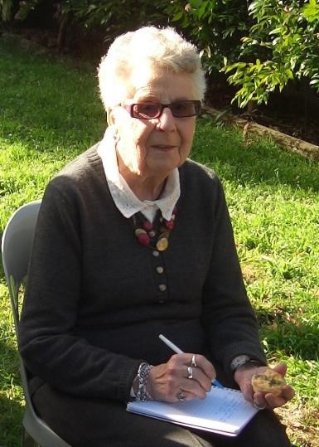
PAM’S PAGE
Glenbrook a Village
Glenbrook is unusual in that there was no first settlers, almost everyone was just passing through. The road was built to cross the mountains, not to develop the mountains. It is believed that there were kangaroo shooters camped nearby to provide fresh meat to Sydney Town. These men were believed to have helped Blaxland, Lawson & Wentworth on the first part of their journey through the mountains in 1813. The explorers had camped in the South-East corner of what is now Glenbrook Oval.

William Cox surveyed and built the first road over the mountains in 1815. It was built all the way to Bathurst in 6 months with only 30 men. ( Road builders of today take note!), These men had a store room & camp near what is now the Glenbrook Lagoon, so they could perhaps be classed as our first settlers. In 1824 Lawson, the explorer, built a second road, known as the Zig-Zag road and today known as Old Bathurst Road. The original Cox road was far to steep on the Lapstone Hill and only lasted 9 years.
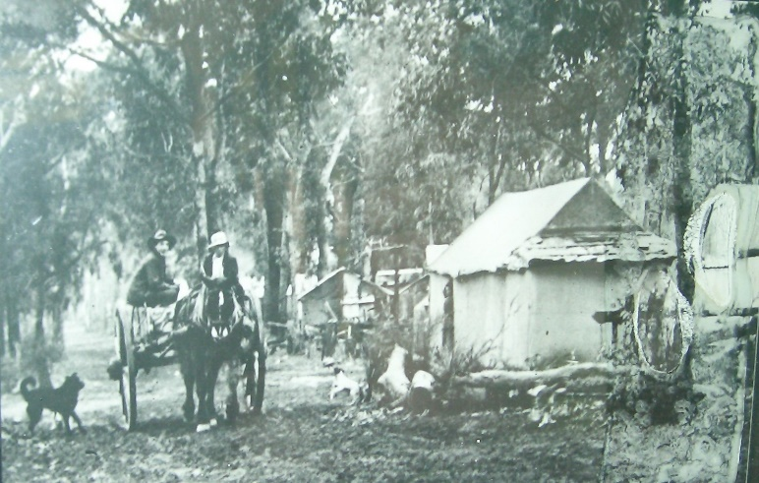
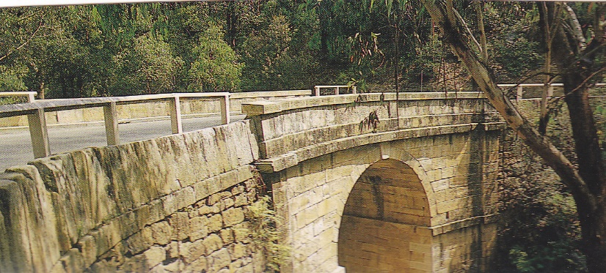
The first recorded building on the Zig-Zag road seems to have been the Pilgrim Inn at Blaxland in 1824.This stood where the Mobile Service Station is today and was a stopover for coaches on their way to Bathurst for many years to follow. Unfortunately it was destroyed by big bush fires in 1968.
Railway Camp The Bluff Emu Rd.
Lennox Bridge Mitchells Pass
Mitchells Pass was the next and third road over the mountains, the bends on the Zig-Zag road were too sharp for the large bullock trains using this route. They had to breakup their load to get around the sharp bends. Mitchells Pass was opened in 1833 but was not named as such until it was officially opened to traffic. The road was steep and the bends were small but quite trafficable, With traffic now using Mitchells Pass, this opened up Glenbrook via what is now Glenbrook Rd. Up until now our only settlers had been convicts and soldiers, but with a better road, people were starting to build holiday houses in Glenbrook. This remained the only road into Glenbrook until 1926 when the Western Highway was made over the unused railway line and then around Lapstone Hill. The Zig-Zag Rd had lasted only 8 years.
In 1865 the first zig-zag railway line was built over Lapstone Hill and then over the mountains. The railway went through Glenbrook over what is now the Great Western Highway. Glenbrook was named 11/7/1867 as “Watertank” and with the coming of the railway came our first permanent settlers, although it was mostly a tent city, there is no record of where the first camp was. As the railway upgraded, so the camped moved to where the Mushroom Tunnel is today.
The last camp was built in 1911 at the Bluff, Emu Rd. This was a large camp and had it’s own shops and Hall. 1874 the railway renamed the station to “Wascoe Siding”. Blaxland was already called “Wascoe” named

after John Wascoe, owner of the Pilgram Inn, this station was near the Inn. The name was
again changed in 1878 to “Brookdale” but this did not last long as the station was renamed Glenbrook 21/4/1879.
We were declared a village in 1885 and a quote from the railway guide of 1886 “numerous country residences have been erected, which provide a cool quiet retreat for busy city workers in the summer, Glenbrook is well laid out and the provision of wild reserves will in time make this place very attractive. The large park close to the shops will help to keep Glenbrook an attractive Village.

EDITOR: Photographs from G.D.H.Society collection. References to Donald Skarratt Snr & Jnr in this edition of the Newsletter come from a taped recording made by Donald Jnr March 1977, aged 62 yrs. He died soon after in 1977. Tapes are held by Mr John Leard owner of “Mountside” Glenbrook
GLENBROOK & DISTRICT HISTORICAL SOCIETY Inc.
OFFICE BEARERS 2018-2019
President: Denis Bainbridge Vice Presidents: Doug Knowles & Joan Peard
Secretary: Neil McGlashen Treasurer: Anton Von Schulenburg
Committee: Pam Thompson Warren Page Ian Dingwall
Glenbrook & D.H. Society Museum is situated within the Old Glenbrook Infants School, Ross St. Entrance via Park or Ross Sts. Museum is open 1st & 3rd Saturdays 9am to 1pm Entrance Free

