GLENBROOK POINTS
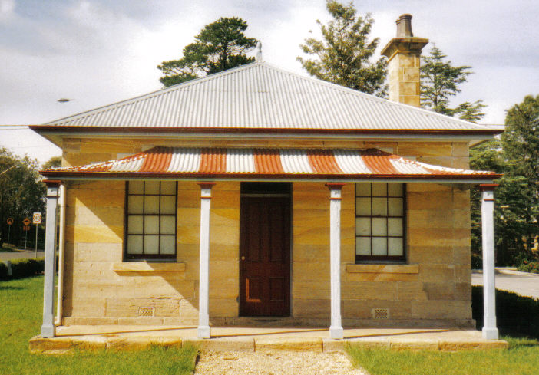
Newsletter of Glenbrook & District Historical Society Inc.

FEBRUARY – MARCH 2019
Postal address P.O. Box 38 Glenbrook NSW 2773
Contacts: President: Denis Bainbridge Secretary: Neil McGlashan 4739 9864
EDITOR W.(Bill) Peard …. E-mail:- jpe13704@gmail.com
E-mail:- gdhs@gmail.com Facebook:- Glenbrook & District Historical Society Inc
Meetings 3rd Wednesday monthly at 1.30 pm (except Dec-Jan) Glenbrook Guides Hall
cnr Hare & Moore Sts. Glenbrook
"HISTORY WALKS" PROGRAMME for 2019.
All on Saturdays: Walks led by Doug. Knowles & Team.
March 9th 9.00am “Lennox Bridge” and the old stone quarry, Brookside Creek,
Dunn’s Steam Saw Mill relics, and earth dam.
30th 9.00am “The Descent to the West:” Mt.York : Three short return walks on the three most historic roads to the West: Cox’s Pass 1815. Lawsons Road 1822 and newest: Berghofer’s Pass 1909.
Includes Tea/coffee, biscuits. Special Walk: 12.00 .
April 13th 9.00am “Eastern Zig Zag Railway” This walk on the 1867 Zig Zag Railway.& Knapsack Viaduct, also extends to the first improvement, the Lapstone Hill Tunnel 1892. [East Portal only,] and the wash-away section 1906.
May 11th 9.00am “Eastern Zig Zag Railway.” This walk is focussed on the Knapsack Gully stone viaduct and offers good photograph opportunities. Includes Gatehouse No. 1, 1867 and the Knapsack refuge sidings 1909.
June 8th 1.30pm “Duck Hole--Glenbrook Creek.” Old roadway construction and pump site for railway water supply to old Glenbrook Station.
29th 1.30pm “The Mountains Murders.” Captain Lee Weller’s grave site and rock inscriptions.
July 13th 9.00am “Faulconbridge Steam Sawmill Site.” Engine remnants and other relics. Operated 1914-1925..
Aug. 10th 9.00am “Bull’s Creek.” Railway relics:- Stone dam and steam pump relics.
31st 1.30pm “Lapstone Construction Railway.” 1910-1913 and east portal of Lapstone Hill Tunnel 1892..)
Adults: $10 (Except for Special Walk.) Accompanied Children under 16yrs. Free BOOKINGS are ESSENTIAL: Phone Doug on 4751 3275. Please allow the phone to ring longer than usual, for details re meeting place, time and grade of walk. Good walking shoes are essential. Please bring a hat and drinking water. (No dogs please.) BAD WEATHER ON THE DAY: Excessive wind or rain could cause cancellation due to hazardous conditions.
Correction: HAMMENT FAMILY 1857-1903 in our last issue, Richard Hamment was listed as a railway fettler, he was in fact a railway gatekeeper at No5 cottage Valley Heights until moving to Glenbrook 1882…further details refer to page 6 this issue.
GLENBROOK VOLUNTARY BUSH FIRE BRIGADE.
By Doug Knowles Past Pres. Glenbrook & District Historical Society.
By about 1940 or so, a group of local residents, George Bunyan as Captain, organised themselves to help the locals with hazard-reduction burning. About 1941 or so, the group was issued with a trailer-mounted pump, powered by a 4 cylinder petrol engine.This was fine if the fire was approaching the lagoon, but there was no town water-supply and they didn’t have a tanker-truck.Town water progressively arrived at about 1942. So, to organise a hazard-reduction burn, you ask Stan Edwards to put the tank on his truck.Then he drives to George Bunyan’s to couple-up the trailer pump. Then, drive to the lagoon to fill the tank, then they are ready to start. As you can appreciate, this set-up is not capable of a quick response ! Blue Mountains Shire Council was supportive and helpful in providing a fire-siren (on a pole, in Ross Street) and also £25 cash to be used to buy tools and equipment.
About 1949, the group decided to ask the Board of Fire Commissioners to set up a fire station and tanker in Glenbrook.The reply was a definite ‘no,’ so the group decided to be independent and do it themselves. First step was to raise the necessary cash for building materials.The Shire Council made a block of land available in Wascoe Street for a Fire Station. Letters were sent to all residents asking for cash donations to support this project.
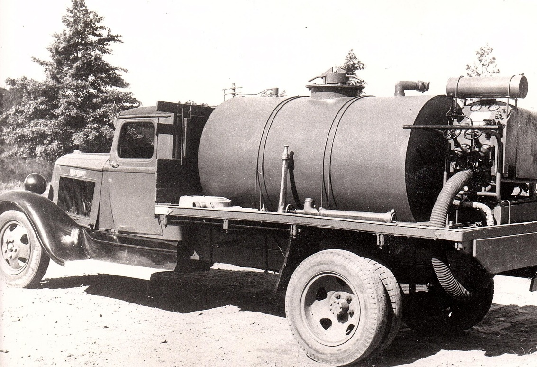
The group now had funds, but not enough to complete the project......should they start? or should they wait until there was enough cash to complete the project.? They decided to start, while interest was keen, funds in hand would provide steel mesh for concrete footings and sufficient for purchase of sand, cement and gravel to get the job to floor level. Voluntary labour will dig trenches, position the steel work, mix and finish concrete floor. No Readymix concrete in those days.
1936 Dodge Truck , Water Tank & Pump
With the project completed to floor level, they then asked the locals to provide the cash to finish the project. All members/volunteers did a door-knock for funds. This yielded enough cash to complete the fire station and set up a fire tanker truck. I remember my father Melton Knowles, saying...”Very successful: those who previously gave 10 Bob, gave 10 Quid.” ! A donation of £10 in 1950 is a substantial sum, and is equivalent in 2018 purchasing power, to about $650
Melton Knowles was regarded as Chief Architect/Engineer/Carpenter and Clerk of Works. Fred Cole and Ted Morris were in charge of the brick-laying team. A tank and the pump were set up on a 2 ½ ton,1936 Dodge truck. With lots of help from the workshop team at the Colonial Sugar Company at Pyrmont, lots of clamps, brackets, fittings and adaptor pieces were made at Pyrmont and assembled at Glenbrook.
So now, Glenbrook Village had a proper fire-fighting tanker truck. Yes, a Fire Engine!! and all provided by local subscription and voluntary labour. A display in our Museum at Glenbrook has photos of this Fire Station, tanker and crew with their names listed. 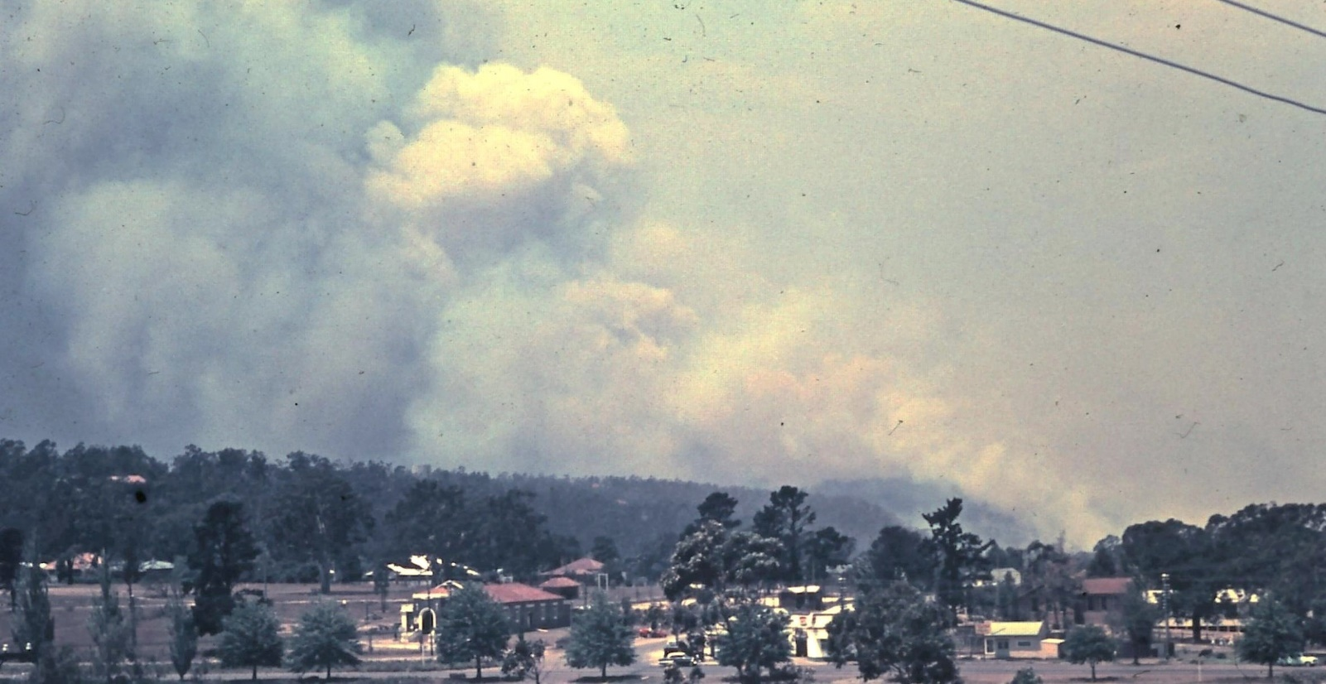
Glenbrook Fire from Moore St.
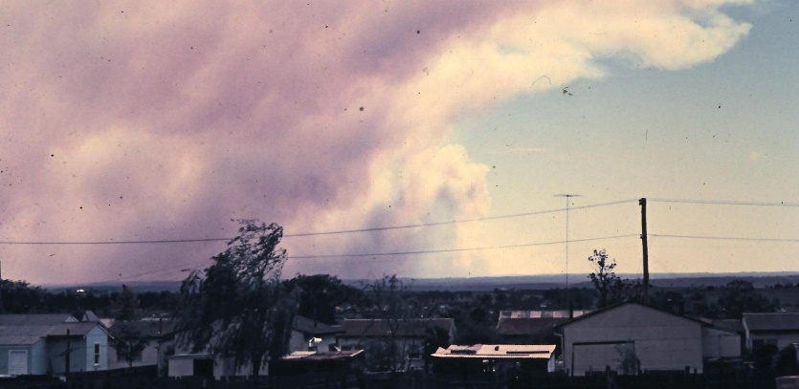
The first big test for crew and tanker occurred on the 6th December, 1951. An unstoppable bush fire swept through. Only 5 houses were lost in Glenbrook. Blaxland lost about 10, Warrimoo even more. So, the village tanker truck and volunteer crew well-and-truly proved their worth. Later on, following much development in the village, in the mid to late 1950’s, the Board of Fire Commissioners decided to provide a modern fire engine and extend the fire station so that it will fit in, and even pay the crew. With George Bunyan remaining as Captain, this suited everybody.The Glenbrook fire engine built by the voluntary crew was transferred to Castlereagh Bush Fire Brigade.This information is compiled from Museum exhibits, and memory, by Doug Knowles for the Glenbrook & District Historical Society’s 25th anniversary. Photos G&DHS Collection
Glenbrook Fire From St.Marys
PAM’S PAGE RAILWAY CAMPS

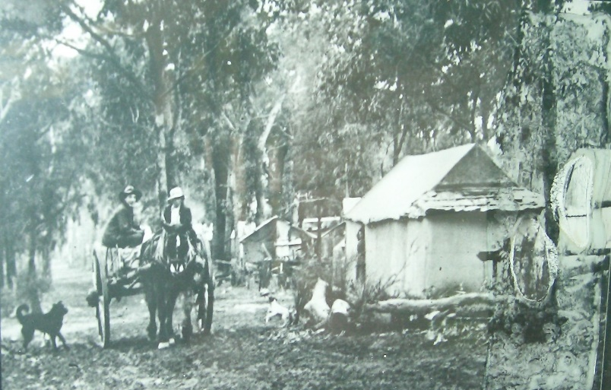
In 1911 work was underway on the railway line passing around the end of Lapstone Hill and on the present tunnel site. The railway employed 800 men on this project, these men lived in three camps, one on the site now Lapstone School, another on the site now Blaxland High School and the main camp was at The Bluff. This was quite a substantial site, with it’s own main street, now Emu Rd. important enough to bring in people from surrounding districts. The railway workmen lived in tents or small shacks with iron roofs and a wall of white washed hession.
Because of the sudden increase in population, extra police were stationed at Emu Plains and Springwood, and for the first time we had a policeman stationed in Glenbrook. This was at “Kalgoola” (now Ilford) House, a guest house in Wascoe St., with lock-up at rear. The closest Doctor was in Penrith.
Railway Camp "The Bluff"
In 1912 there were 19 shops listed in Glenbrook, including 9 general stores, but the closest bank was in Penrith. During these two years Glenbrook had two cricket teams who played their matches on Glenbrook Park, and dances were held in Union Hall main camp, with prizes offered for finest evening dress. At the same time functions were held in the newly built School of Arts and silent movies were being shown in Penrith.
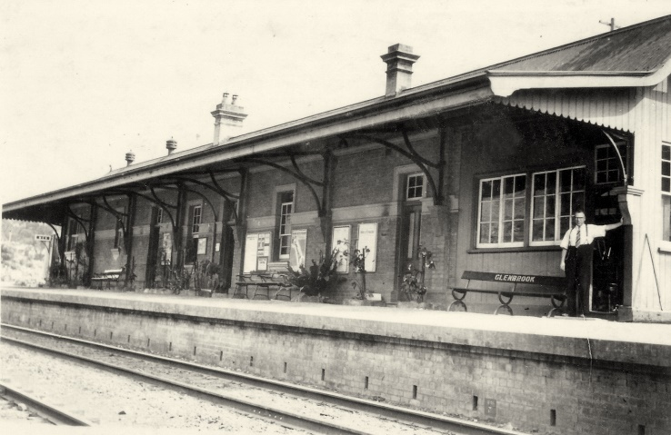
In the early days residents were expected to collect their own mail, but in late 1911’s, letter delivery was arranged for the railway camps. By May 1913 most of the workmen had left the site and on 25th September 1913 the old line was closed, the weeds grew, and the old Glenbrook Station stood alone and deserted. The tea rooms that served ‘Goldenia” tea had no customers and closed.
The Station Master continued to live in his stone residence, now “Pointsman’s Cottage”, although he had to walk down the hill to the new station at bottom of Ross St. With the coming of the new railway line, Glenbrook slowly grew from being mostly holiday cottages to business people’s homes, travelling daily to work in the city and return , using the fast steam train service now in place.
Glenbrook Railway Station 1920


From The Secretary’s Desk

.
RAAF 1941 Plaque Clifton Avenue: Looking at upgrading the plaque at Clifton Avenue for the 80th Anniversary – 28 January, 2021. Suggest that both plaques be dedicated on the same day (R.S.L. cenotaph) if possibly some descendants would need to be invited. Descendants that were there at ceremony 1994 none would now be around. Not looking at changing the plaque but possibly putting a little fence and some stones around it.
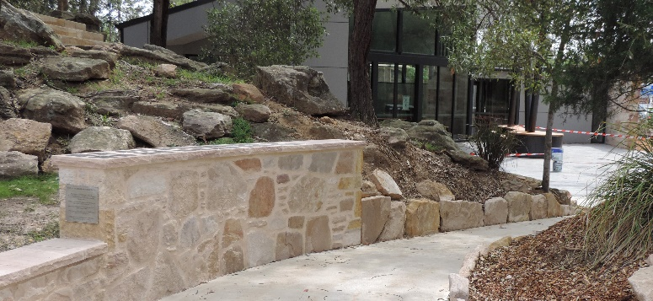
Pioneers Wall Family Plaques: Doug K.– I have passed around a list with family names we are looking at and whether we think they should go onto the Pioneers Wall once it is ready along with the existing plaques. Today not looking at discussing which ones should or shouldn’t or their importance or any hierarchy. Just if anyone knows of someone connected to these family names who can be contacted. The only criteria is a family lived in Glenbrook before 1950, plus the cost of the plaque $175. 140m x 110m embossed.
New Pioneers Wall 2018

Lapstone Hill Railway Tunnel: Elizabeth S.–contract has been given to take out the free standing metal stands that go 150 metres into the tunnel. Also take out the small link metal chain secured every 2 metres and going 300 metres into the tunnel.. They thought all asbestos had been removed in 2017 but found it still has some contamination on the surface. To get this removed and once clear to cap the site with crushed sandstone. Ventilation infrastructure on the top of the wall of the Western Portal has damaged brickwork, If any money left over from current grant they will start on mushroom compost removal. Council expected to remediate walking track from Knapsack Street to Western Portal and doing bush regeneration work.
Internet access: Pres Dennis to arrange connection to museum computer over xmas break, $99 connection plus $14/month.
Archive/Catalogue report: E-Hive program on trial for past 6 months, fits all needs but installation to be held back until internet connection made, then reassessed.

Did You Know??? Some Trivia
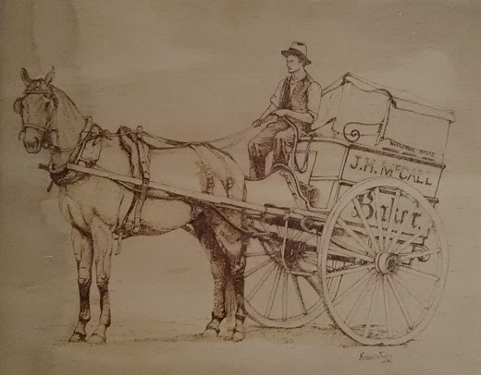
Lennox bridge was subject of some controversy soon after it opened 1833. Surveyor General reported that a crack had developed in the foundations. Designer, David Lennox investigated and replied “entirely without substance”. The bridge was closed because of a crack in 1962.
McCall’s bakery in Mann St., opened in 1946, was one of the largest employers of labour in the Blue Mountains. They delivered household bread from Glenbrook to Bullaburra daily. At one stage their delivery van fleet was 17 vehicles.
Blaxland Railway Station, opened 1867, was originally named Wascoe, after the owner of Pilgram Inn, John Outrim Wascoe. The Inn was located at the junction of Old Bathurst Rd. and Cox’s Rd. In 1832 this Inn was described as “….one of the cleanest, most convenient in the country”.
McCall's 1st delivery van
Glenbrook Railway Station in 1878 was named Brookdale by Sir Alfred Stephen M.P. who claimed the name was “pleasant and suggestive of water & high ground”. The station had been previously named Watertank (1867) then Wascoe’s Siding (1874) and lastly changed to Glenbrook (1879). State Rail Authority have no archival records as to why the last change was made from Brookdale. Glenbrook Village was not gazetted until 1885.
Sarah Hamment, wife of Richard Hamment, whilst living at No5 Gatekeeper’s cottage Valley Heights, would accept the mail left by the mail train. She became the Postmistress when an official Post Office opened in December 1876, and until moving to Glenbrook in 1882.

Bella Vista Trip 19 November 2018…… Pam Pascoe activities officer
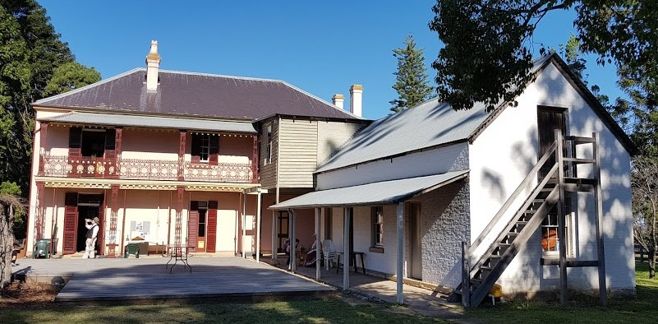
Seventeen members attended this trip on a fine day. We were met by Val Barton our guide for the visit who greeted us at the gate and allowed our bus to travel all the way up to the house. We were provided with a lovely morning tea whilst at the same time participating in a quiz and prizes identifying old items of interest. Val along with another keen volunteer gave us a talk on the families associated with the house and the property history. The old farm house that housed the Macarthur Family which included seven children is still standing. The gardens are also attended to by volunteers. We roamed through the many rose gardens and stood on the balcony overlooking the surrounding land that had many Bunya Trees and it indeed was quite a vista towards the skyline of Sydney. The property had its own store for its workers. It has a steep staircase that took us to the bedrooms and a school room that was built in later years. Downstairs housed many photographs and information sheets.
Bella Vista
The property is owned by the Hills Shire Council who contribute along with several Grants received over the years and this has funded the repairs and maintenance for the building and grounds. It is an ongoing project. After leaving “Bella Vista” our good driver John conveyed us to the Blacktown Workers Sports Club. A buffet lunch was enjoyed by all and we eventually boarded the bus back to Glenbrook.
As Activities Officer it was pleasing to have so many attend, and thank you everyone for punctuality which allowed us to keep well within the planned schedule. Also many thanks to John Dikeman for his help in collecting the bus and transporting us for the day.

Memories of Glenbrook in 1949
By Lorna Hatherly (written 1999)
My memories of Glenbrook begin in 1949 when Max and I were married and lived in Wascoe St. Newly married we considered ourselves lucky to have found a house to rent even though it cost us a relatively high £2/2/- per week ($4.20). Not too far from the station and from Lidcombe where Max worked and near the bush which we both loved. The 2 bedroom fibro house was only a few years old but it’s fuel stove, chip bath heater and fuel copper hardly matched the housing of Sydney, this was really country. But we did have water laid on even though the new rainwater tanks were a reminder that this had only happened recently.
Lack of water also explained our sanitary system. Everyone had a little house down the back yard with weekly pan service provided by the Council. The fresh pans smelled distinctly of tar , or was it carbolic acid, that was used to disinfect them. The sanitary cart had a double row of doors down each side into which the tightly lidded cans were pushed by the carter. It all happened in the small hours of the morning so that we hardly saw anything. However we certainly heard the clanging of the cans and the barking of the dogs and we certainly saw, and smelled, the broken down trucks that were sometimes left at the side of the road.
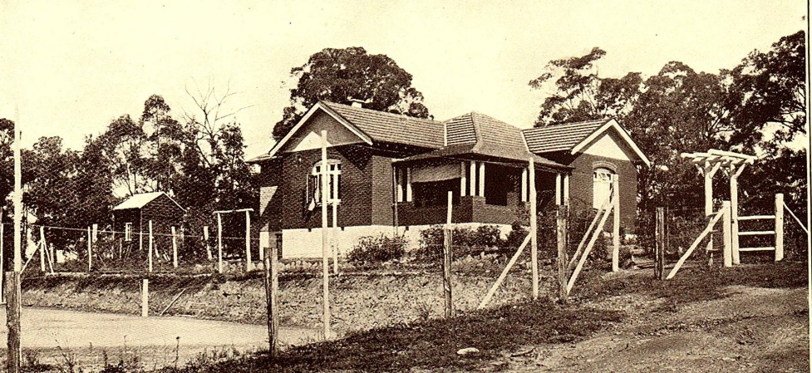
The recent need to conserve water also explained the open aspects of the houses and gardens. There was very little evidence of the lush growth now seen everywhere but, there were lots of tennis courts with houses on larger blocks of ground. Most of them had fallen into disuse.
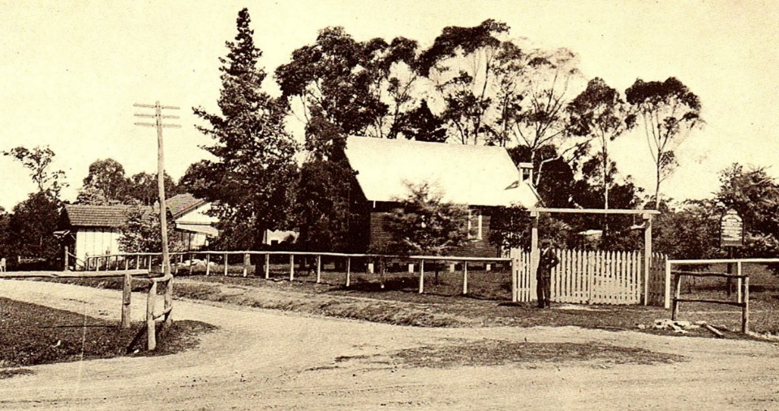
Milk was delivered each morning by Mr Bunyan direct from the churn. We bought a beautiful aluminium billy with a tight fitting lid and this was left at the front gate. When bottled milk appeared some years later we had a very superior billy for our picnics at Glenbrook Creek.
Tennis court Doug Smith’s residence Station St. c1925
On the corner of Wascoe St & Raymond Rd. was St.Peters Church, a small weatherboard building now moved from it’s corner position and used as a Sunday School. I remember being told about an earlier time in the village when everyone, church goers or not, joined forces and moved it from it’s original site somewhere up the hill, near St.Finbars, to be close to the centre of the village. ( EDITOR: Moved in 1923 by Mr J. Venn from 9 Hare St.).
St.Peters Church foreground & Post Office background c1925
Next door to the Church in Wascoe St was a grocers shop owned by Mr & Mrs Warwick and in
Raymond Rd. the Post Office and telephone switch which were run by Miss Moore and Miss Beatrice Simpson. The office and switch were in the front room of the house, which had double doors from the front verandah. Outside on the footpath was a public phone box. In those days our phone book covered the area from Penrith to Broken Hill. I wish I had kept that original book. Glenbrook numbers took up about a quarter of a column, even less than Glen Davis the next town on the page. Opposite where the school fence now is, was a small creek, mostly dry and lined with wattle trees. The trees were a spectacular sight when they flowered in the spring.
The next house down from the Post Office had a small shop built at the front fence. It sold haberdashery on one side, skeins of wool at the back and also had a few bolts of cloth. The other side of the shop had a library of well thumbed books that could be borrowed.
At the left hand turn from the highway into Ross St. was the School of Arts, it had a cement horse trough at the side. In front of the old stone house on the opposite side of the street were some petrol pumps and a shed where Mr & Mrs Forrester ran their garage. Very few of the residents had cars and we had no need for their services.
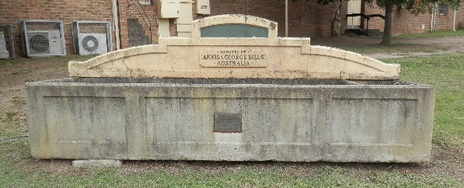
The 2-teacher public school had a newly built weather shed and on the opposite side of Ross St were four tennis courts. I had grown up with love of tennis and a story of my father having played in a competition match at Glenbrook that had lasted so long that it had to be continued the next day. For many years this was recorded in the tennis shed as a marvellous event. On the side of the present supermarket Mr Potter had his shop, he sold newspapers, fruit, vegetables, sweets and ice cream. The shop had just had an extension built to the side and here the Balcombes had a grocery store. On the corner of Park St a large weatherboard carpenters and joiners shop was run by Mr Watts and a little down Ross St was the butchers shop.
“Bills” Horse trough 2018
Being a city girl, I thought the butchers shop was very old fashioned. As you opened the screen door and entered you faced a wire screen partition, which had a door and window hatch and divided the shop into two areas. The customers sat on a high wooden bench with their backs to the window and street. When your turn came you walked over to the screen and asked for your cut of meat. Pat or Maurie Roots then went into the cool room and brought out a side of carcase, hung it on one of the hooks on a rail that ran along the side wall, and cut off the required portion. This was taken over to one of two chopping blocks, in the centre of the shop, for trimming and final cutting, before being brought across to the counter on their side of the screen.
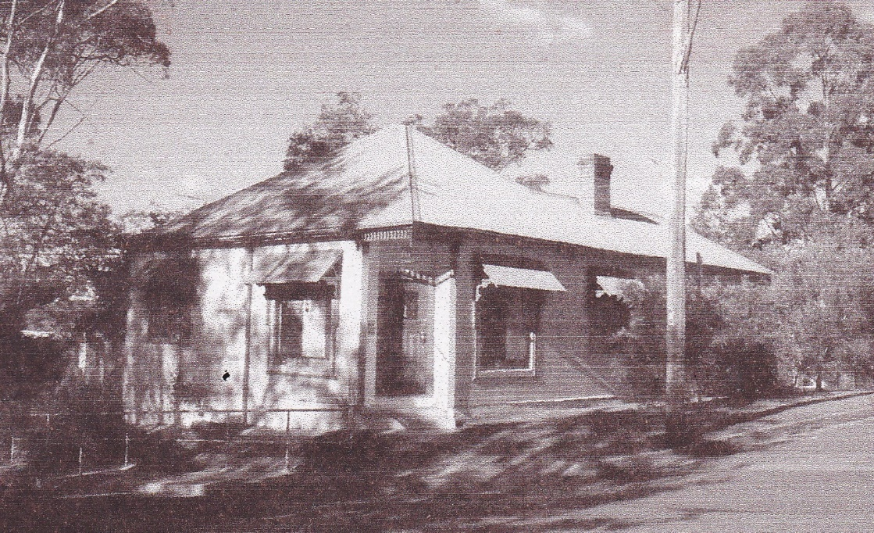
The next shop before the railway station was a cake shop on the corner of Glen and Ross Sts. The cook, Mrs Billie Ryan, had a very successful business, making meat pies, lamingtons, rock cakes, and fruit slices. A few years later it was sold to a migrant from Europe, who made exquisite pastries and tarts. Unfortunately in those days Glenbrook liked more traditional fare. I can remember, I suppose to help business, that he rode around on his push bike with side car packed with goodies, dressed in his white apron and chef’s cap.
Shop Cnr. Ross St &. Glen St. c1925
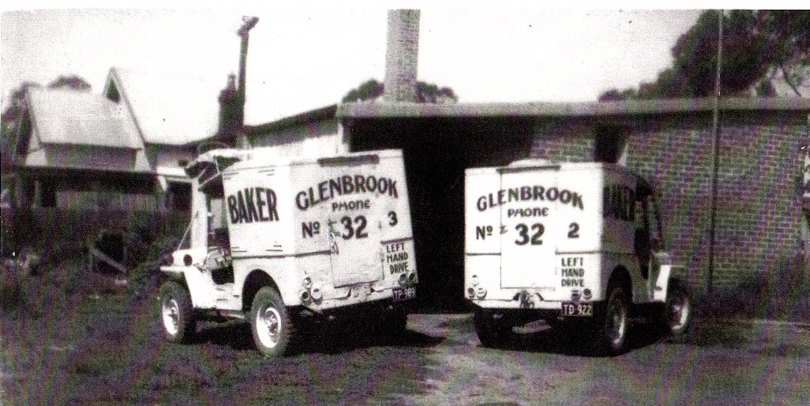
In Mann St. Mr Brooks conducted his Stock & Station Agency from an office in his home and next door the McCall’s had a bakery in their back yard, their house faced Cowdery St .No resident at the time will have forgotten the smell of their newly baked bread. In the small shop nearby Mr Carey combined the roles of Estate Agent and taxi proprietor.
And now for a disadvantage, which everyone accepted as a matter of course. There was no Doctor in the village but either Dr Uren Penrith or Dr Baxter Springwood would come for house calls. They would give their local Pharmacy the prescription and it would be delivered by the driver of the Mountains bus with instructions as to the bus stop to make their delivery. Someone would be waiting.
McCall's Bakery delivery vehicles c1949
So now in May 1999, and looking back 50 years, I can see that Glenbrook was on the brink of the post war boom that changed all of our lives. Progress?

GLENBROOK & DISTRICT HISTORICAL SOCIETY Inc.
OFFICE BEARERS 2018-2019
President: Denis Bainbridge Vice Presidents: Doug Knowles & Joan Peard
Secretary: Neil McGlashen Treasurer: Anton Von Schulenburg
Committee: Pam Thompson Warren Page Ian Dingwall
Glenbrook & D.H. Society Museum is situated within the Old Glenbrook Infants School, Ross St. Entrance via Park or Ross Sts. Museum is open 1st & 3rd Saturdays 9am to 1pm Entrance Free

