GLENBROOK POINTS

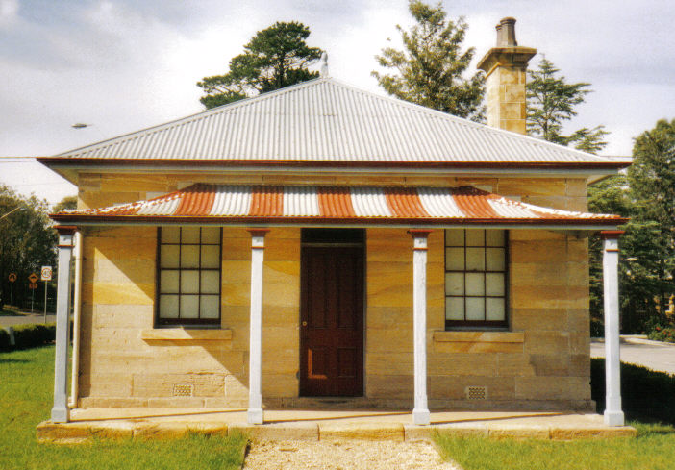
Newsletter of Glenbrook & District Historical Society Inc.

AUG-SEPT 2019
Postal address P.O. Box 38 Glenbrook NSW 2773
Contacts: President: Denis Bainbridge Secretary: Neil McGlashan 4739 9864
EDITOR W.(Bill) Peard …. E-mail:- jpe13704@gmail.com
E-mail:- glenbrookdhs@gmail.com Facebook:- Glenbrook & District Historical Society Inc
Meetings 3rd Wednesday monthly at 1.30 pm (except Dec-Jan)
Glenbrook Guides Hall cnr Hare & Moore Sts. Glenbrook
"HISTORY WALKS" PROGRAMME for 2019.
All on Saturdays: Walks led by Doug. Knowles & Team.

Aug. 10th 9.00am “Bull’s Creek.” Railway relics:- Stone dam and steam pump relics.
31st 1.30pm “Lapstone Construction Railway.” 1910-1913 and east portal of Lapstone Hill Tunnel 1892..)
Sept. 7th 9.00am “Glenbrook Lagoon Precinct.” Early campsite and railway dam
construction 1880 for water supply to the first Glenbrook Station.
28th 9.00am “Glenbrook Heritage Walk.” Historic sites, houses and West
Portal of Lapstone Hill Tunnel--1892.(Last Walk for the year.)
Adults: $10 Accompanied Children under 16yrs. Free BOOKINGS are ESSENTIAL: Phone Doug on 4751 3275. Please allow the phone to ring longer than usual, for details re meeting place, time and grade of walk. Good walking shoes are essential. Please bring a hat and drinking water. (No dogs please.) BAD WEATHER ON THE DAY: Excessive wind or rain could cause cancellation due to hazardous conditions.

Error Pam’s Page June-July 2019: “The Glenbrook pioneers wall was situated at the Glenbrook Visitors Information Centre and was officially opened on 20th March 2008. This was a project of the Glenbrook & District Historical”. This was reported incorrectly as 20th May 2008, a typographical error. Editor

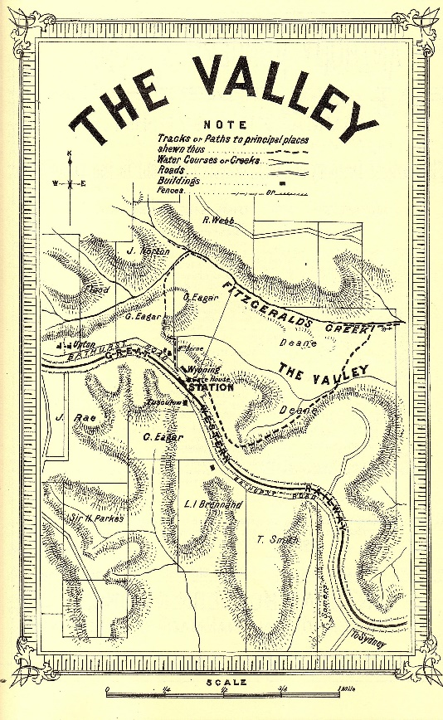
Pictorial Guide
to the
Blue Mountains N.S.W.
Published 1882 page 22

The Valley, 46 miles from Sydney, 1048 feet above sea level. Is the name given to the prospect which opens on the view hereabouts. A lovely vale of grassed undulating land, lightly timbered and well watered, presents quite an English park like appearance.
But instead of huge gnarled oaks, beeches and elms, we have here colossal eucalypts, syncarpias and other majestic indigenous timber, while the rocks with which the gullies are faced are everywhere clothed with a wealth of ferns of immense variety.
Gleichenias, Adiantums, Dicksonias, Pteris, and a host of other forms valued by collectors may be gathered here in waggon loads. If the fortunate owner of an acre of this country could but transport its vegetation unimpaired to London or Paris, he would quickly find himself a wealthy man. Varieties , which are abound here, are frequently sold in London at from three to ten guineas ($6.30-$21) per plant
The visitor is especially advised not to leave the Valley without seeing the locality of Fitzgerald’s Creek, the upper portion of which is very rich in ferns and the indigenous flora usually associated with these mountain rivulets. By following down the Valley road for about 100 yards, taking the line of a wire fence to the left, and then turning sharply to the right over the rise, the tourist comes across some most charming scenery. The climate is remarkably mild and equable, and well suited to invalids, who may forget their ailments.
The principal residences in the neighbourhood are those of Messrs J Rae, I Brennand, W(BillA) Deane, “Upton” the property of W Dawson, and “Wyoming the property of Mrs Berne. Good accommodation may be got at “Tuscalum” and at “Wyoming”, both near the station and as shown on attached plan. A whole day may be profitably spent in exploring the varied beauties of Fitzgerald’s Creek, its leaping cataracts and placid reaches, edged with mountain moss and ferns, as it hurries along its course to Nepean River and to the ocean.
EDITOR: This is an abridged version of an article published in 1882, a tourist guide, by Gibbs, Shallard, & Co .and refers to what is now “Valley Heights”.

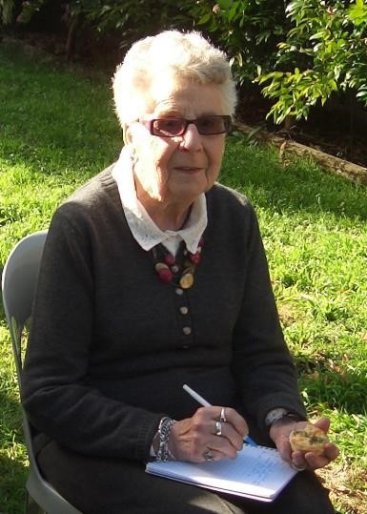
PAM’S PAGE

Did You Know??? Some Trivia

From The Secretary’s Desk



.

GLENBROOK & DISTRICT HISTORICAL Soc. Inc.
OFFICE BEARERS 2018-2019 President: Denis Bainbridge
Vice Pres: Doug Knowles & Joan Peard
Secretary: Neil McGlashen Treasurer: Anton Von Schulenburg
Committee: Pam Thompson Warren Page Ian Dingwall
Glenbrook & D.H. Society Museum is situated within the Old Glenbrook Infants School, Ross St. Entrance via Park or Ross Sts.
Museum is open 1st & 3rd Saturdays, 9am to 1pm, Entrance Free
APPLICATION for MEMBERSHIP of ASSOCIATION
(Clause 3 (1)

GLENBROOK & DISTRICT HISTORICAL SOCIETY Inc.
(Incorporated under the Associations Incorporation Act, 2009.)

P.N: Would you please use a black pen and write firmly.

I: ............................................................
[Full name of applicant:
of: ............................................................................................................
[Address]

Phone:..................... Email: ...................................Occupation..............................

hereby apply to become a member of the above named Incorporated Association. In the event of my admission as a member, I agree to be bound by the Constitution of this Association.

Signature of Applicant: ....................................Date: ..................

Please enter your choice of annual fee from the separate price list.

$............. plus joining fee: $5.00 = Total $...............

I give permission for my telephone number and email details to go on a list for members only use. Please tick if you agree

For insurance purposes, please indicate age category: [18 - 50yrs ..…] [51 - 70yrs .....] [71 – 85yrs..…] [86yrs + .....]

Please send this completed Application Form to:
Secretary
Glenbrook & District Historical Society Inc
PO Box 38 Ph: 0420 660 388
GLENBROOK NSW 2773 Email: glenbrookdhs@gmail.com

Or: Bring with you to the next meeting: Every third Wednesday of the Month, (except December & January,) at 1.30pm at the Guide Hall, Cnr. Moore & Hare Streets.

We look forward to seeing you at our next meeting or event:
From the Management Committee.

3/19.

