Faulconbridge Sawmill Denis Bainbridge 4/18
Some of the following information was published in Bulletin 40 1/82 of the Springwood Historical Society. Other information obtained by scanning old news articles.
The initial 60 acre Portion 53 land was purchase on July 15, 1909 by Henry Joyce. Further purchases were made for 70 acres Portion 54 on August 26, 1909 and Portion 55 382 of acres on September 28, 1911. Portion 55 bordered the end of Highland Road and to the north connected to Portions 53 and 54. Other land purchases must have been made as in the end there was 630 acres.
Working through old newspapers we can find two very interesting articles. In February 1912 a SMH article outlined a major business at Faulconbridge The “Defiance Cabinet and Chair Making Company run by a Mr George Mitchell of Sydney who were going to source Grose Valley hardwoods for furniture making. The logs will be raised by an already built railway to a factory close to Faulconbridge Station for processing. Special machines will mass produce up to 19,000 chair pieces per day which will then be shipped to Sydney for final assembly. It was planned to compete with a Canadian Chair Making Company that exported all over the world and faced a 30% local duty. The article stated that work had been going on for two and a half years at Faulconbridge which would soon be humming to the sound of machinery. If this is our incline than it would have been built well before 1912. Nothing further has been found about this proposed company or that any factory was built near Faulconbridge Station.
To make this matter more interesting it was announce in the SMH in September 1912 that a prospectus had been release for a new company “Mutual Investment Provident Company Limited for the issue of 2,500,000 one Pound shares.
The initial office holders in the proposed company are;
Mr C McLeod Manager
Mr J L Harcas Accountant, Secretary and temporary office. 87 Pitt Sreet Sydney.
Mr Henry Joyce Engineer and Timber Expert , Fern Gully. Faulconbridge
The company prospectus outlined all the areas they intended to conduct business in the building and furniture areas. In the timber holdings one of the areas was Faulconbridge with a holding of 512 acres and later 1500 acres which had 21,000,000 super feet of timber. These reserves had been qualified by Wm F Kullam Esq timber expert and John S Allan Esq. Late Inspector of the NSW Forestry Dpt.
No records have been found if the company was formed. There were critics in the press about the estimates of the amount of timber available.
It was thought that in 1913-14 a steam driven timber mill built (either by Joyce alone or the proposed company) in the Linden Creek valley on a small tributary to Linden Creek . A 900 metre long one metre gauge tramway incline track was built using 4 inch hardwood rails fixed to rough bush sleepers with some on a raised track bed over the difficult terrain. When you see the remains of the boiler today it is hard to imagine how it was transported to the valley floor as it is estimated to weigh over 7-8 tons. The weight of the steam engine is unknown as the only remains are a 18 inch throw crankshaft. It is assumed a wood fired steam winding engine was installed at the top of the tramway incline to raise the carriage while they would have been lowered under a brake or a reversing winder with power in both directions.. There is no evidence of foundations for this engine at the top of the incline. When you consider the seven strand 1.5 inch diameter steel cable remains found in the valley if this was the cable used in this winder the size of the winding drum required was a large piece of equipment. There is little evidence of water supply at this site to supply a large steam engine. Some rusted remains of steel water tanks are in the bush before you get to the possible winder site. Near these remains is a possible small rock dam
It is difficult to determine the layout of the sawmill plant on the valley floor as the area is rough and there is little left work out the possible configuration. How they moved the logs around is difficult to imagine. The mill has been described as a barn type building without walls. The remains we have now are;
An approximated 60 HP Colonial boiler missing end sections installed in stone wall foundations, the boiler firebox door frame, a section of water or steam pipe, a large diameter thin wall steel section which has been claimed as a flywheel which looks like the brake band and operating levers.. Some steel mechanical parts use unknown, a large 18 inch throw crank shaft buried vertically in the ground and some stone foundations. Away from this plant laying in the creek are two sets of trolley wheels with one metre gauge with cast iron wheels with steel spokes and sections of the 1.5 inch steel cable.
The Colonial style boiler was popular for use in timber mills near rivers. They were good steamers using wood fuel. Using the reverse flow design they were compact, easy to clean and maintain. They usually operated at a pressure between 90-100 PSI.
The boiler at this site is 12 feet long, 6 feet diameter with 48 4 inch fire tubes. Some fire tubes have been sealed due to steam leaks. The boiler is mounted between sandstone block walls with its brick firebox underneath. By checking the diagram below we can see the housings on the ends are missing one being the baffle that directs the flue gas into the fire tubes where it exits up the chimney. The steam generated flows into the header on top of the boiler. Feed water is injected into the boiler via the pipe on the bottom of the boiler. This a fairly large boiler of this type and would require a lot of wood and water to keep operating. It is estimated that there is 950 square feet of surface heating area which would evaporate around 3800 lbs (380 gallons) of water per hour generating 60 HP for a boiler in peak condition. I suspect that this boiler wouldn’t in peak condition as several fire tubes had failed and had to be sealed.
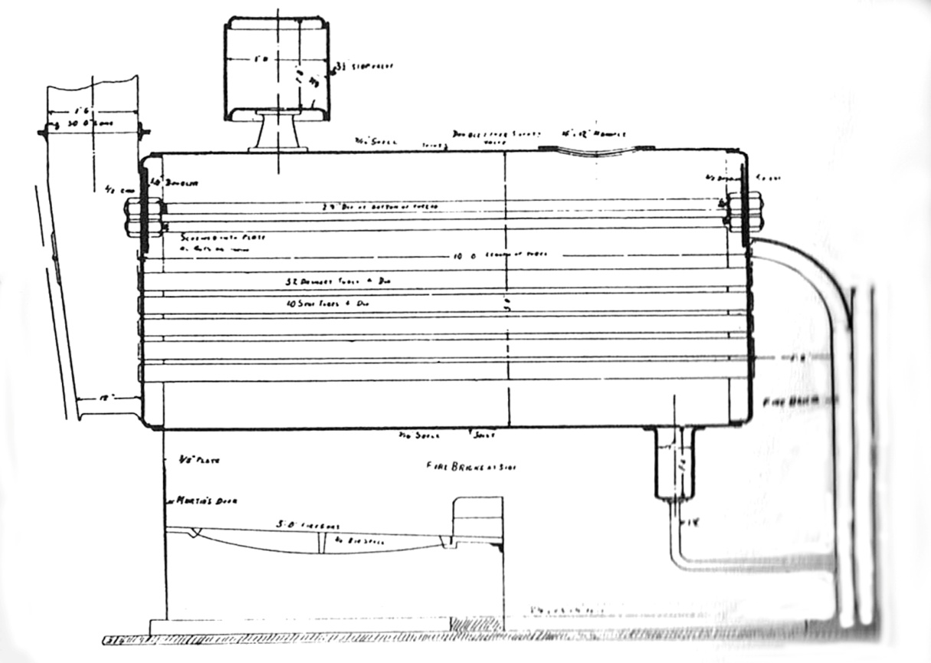
Typical Colonial Boiler Outline
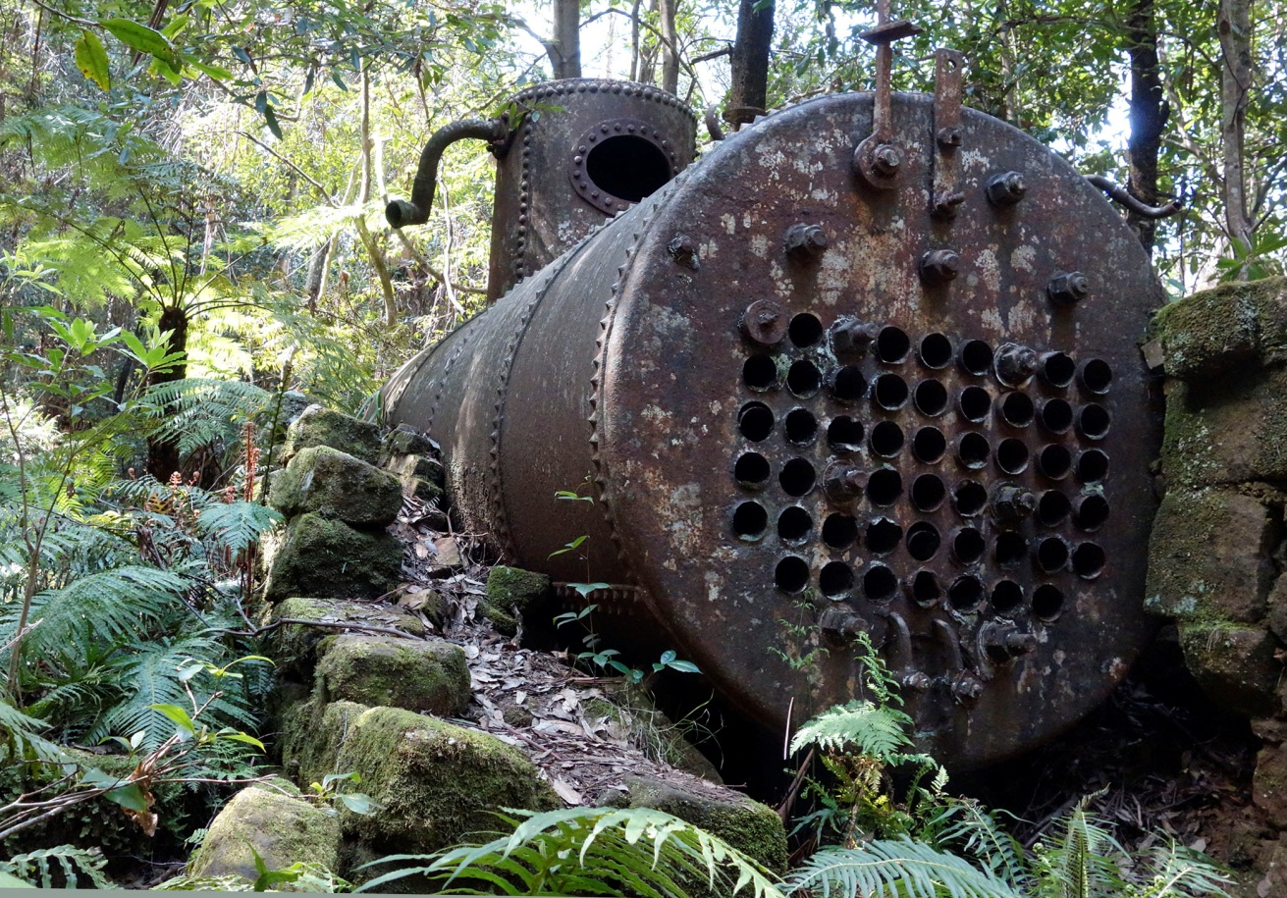
Boiler on Site. Chimney Housing and Firebox Door Missing

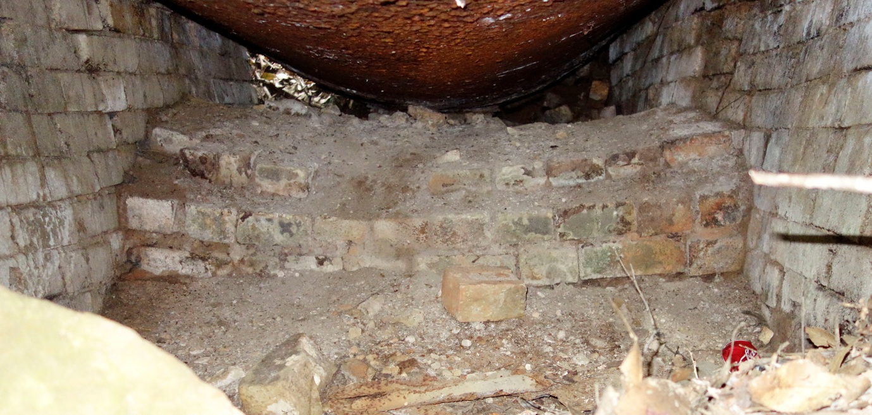
Firebox lined with Fire Bricks
It appears to be missing a grate assembly fitted to this boiler. The effect of the fire on the boiler shell can be seen.
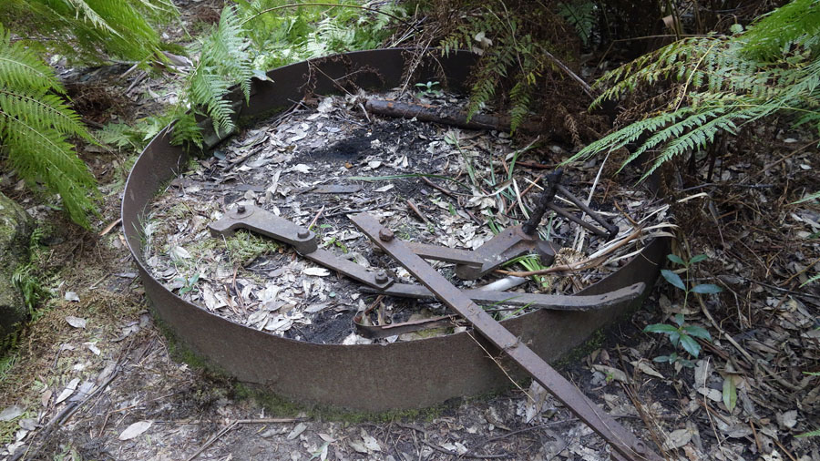
Unknown Parts
The parts in the photograph above have been previously described as a flywheel which isn’t correct. When researching machinery used in the early 1900’s it appears to be a brake band as used in strap brakes and its operating lever assembly. The band fitted around a large wheel on a winder for example and by pulling on the brake lever the band tightened on the wheel to slow its motion..
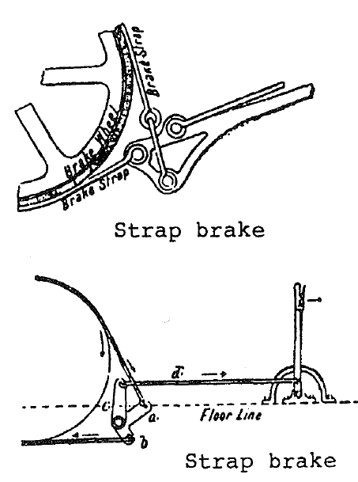

Drawings of typical strap b rake assemblies used in early machinery.

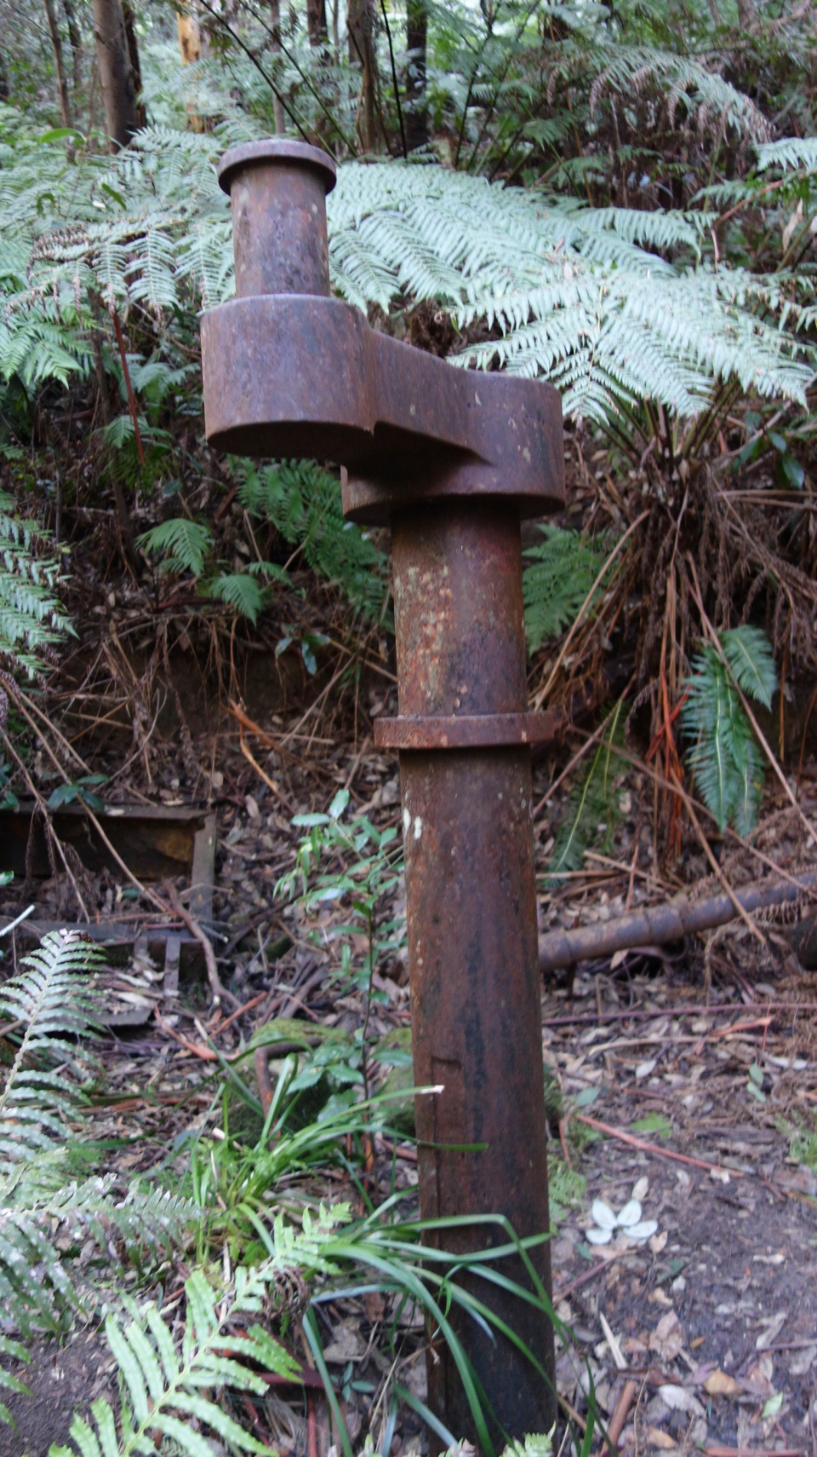
Other Items
Located near the boiler is a large steam engine 18 inch throw crank shaft buried in the ground. Why this item was left in this way is a mystery. It would have been from a large engine and one suspects that it is possible that it may be connected to a flywheel which is buried. In the background on the left can be seen the frame for the firebox door while on the left is some of the steam or water piping laying about the site.
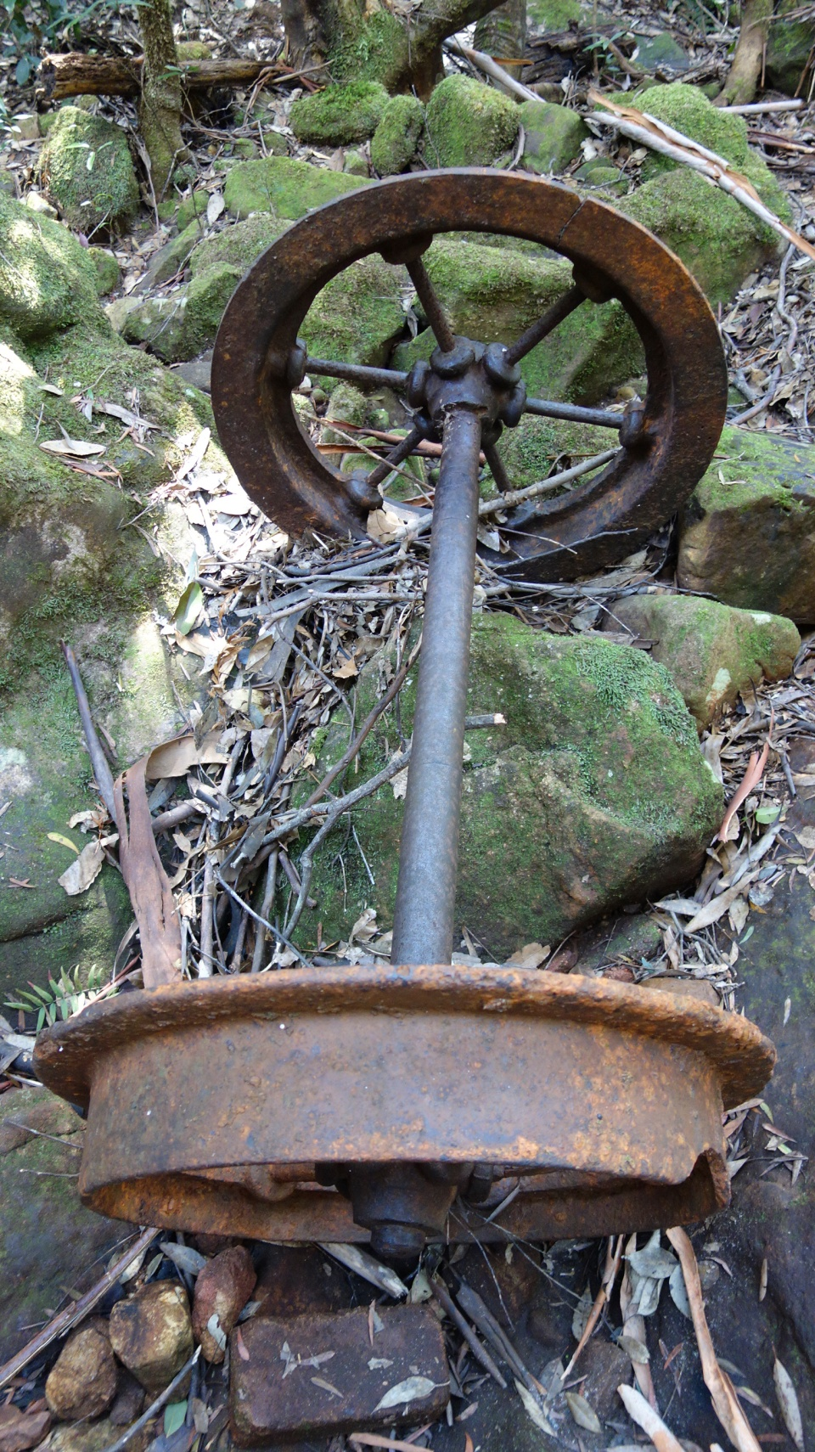
Carriage Wheel Set
This is one of the two sets of carriage wheels on the site. One is located in the creek while the one above is on the side of the creek. The wheels are one metre gauge which suggests a European origin. They are constructed with cast iron hubs and rims with steel spokes. Their solid construction suggests a heavy duty operation capability. If as suggested the boiler and sawmill plant where lowered on the incline then would require very heavy duty equipment indeed for the track, carriage and winding machinery to control the decent.
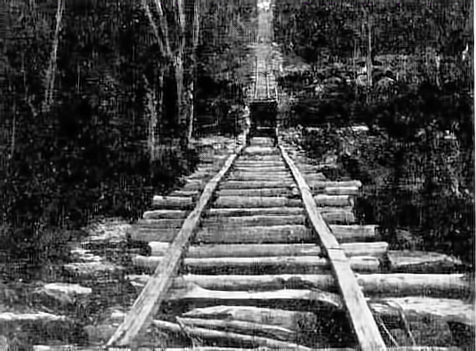
Print in SMH Newspaper article February 1912

This cleaned up print published in the SMH February 1912 article about the Defiance Cabinet and Chair Making Company building a railway to lift timber out of the Grose Valley. . It has 4 inch hardwood rails on rough bush sleepers. The article stated it was taken from the top, however, there isn’t any sign of the haulage cable from the winding engine to the carriage. The resolution is poor so we cannot have a good look at the carriage and its wheels. Further investigations have revealed that this incline could be one in the Parkes Estate area and checking streets in this area was found to be very close to Martin Place Faulconbridge. This photograph may not be our incline as it would have been on the other side of the ridge to the Grose Valley
The photograph below from the BMHS collection is supposed to be an incline in the Parkes Estate. The incline is obviously showing a neglected structure. There is no record found of an incline in Faulconbridge other than the Linden Creek incline. Looking at the two photographs the inclines look similar. The Linden Creek incline we think had metal covering over the rails to stop wear on the rails (metal found in the bush near the incline track). This incline doesn’t have this covering.
Standing at the bottom of Martin Place Faulconbridge and looking up the grade is very close. Some rocks could have been worked to fit an incline.
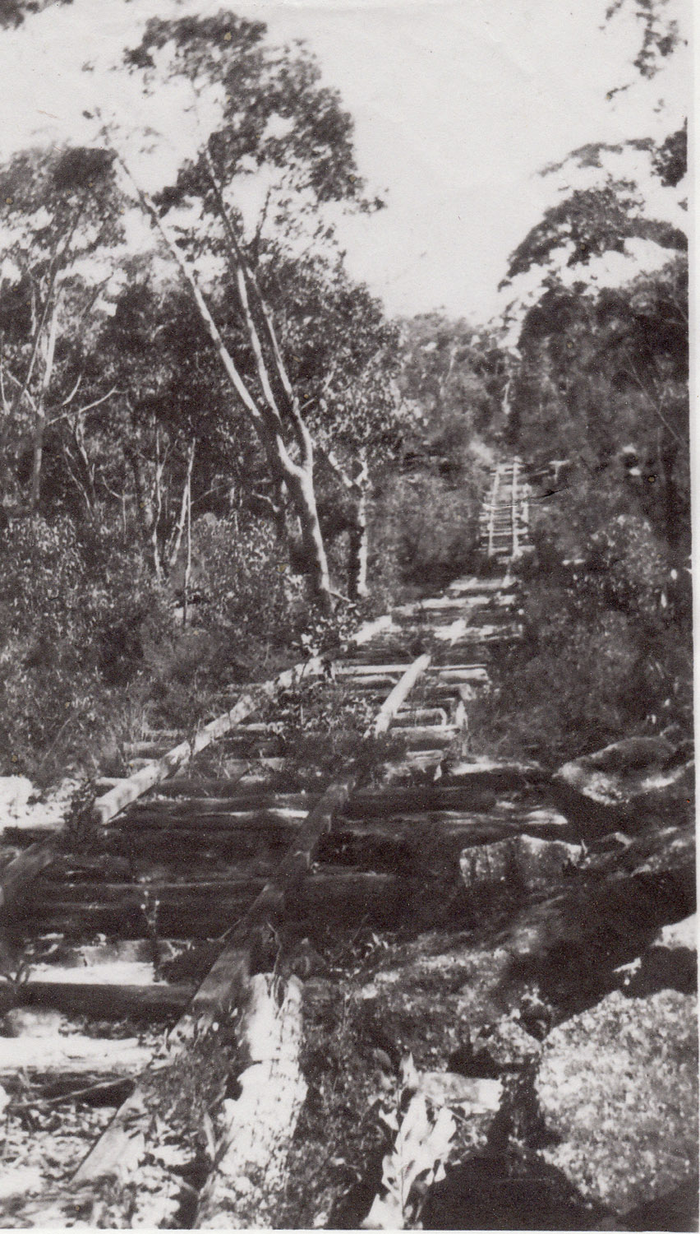
Parkes Estate Incline BMHS

If the photographs we have are not of the Linden Creek incline its construction would be similar in appearance. The lay of the ground at this site isn’t flat and it is said that the incline was built up on timber frame work.

One can only imagine the amount of work and capital cost to install the sawmill and incline as this is rough country. Also how heavy equipment was lowered on this track with such rough sleepers to support the weight remains unanswered. The article mentions a grade of 1:2.
The sketch map below was published in the Springwood Historical Society Bulletin No. 40 January 1983 in an article “The Faulconbridge Sawmill” written by S. J. Bently. The only question about this map is the turn in the tramway track at the bottom. This would be difficult with a long cable driven by a winding engine at the top of the track.
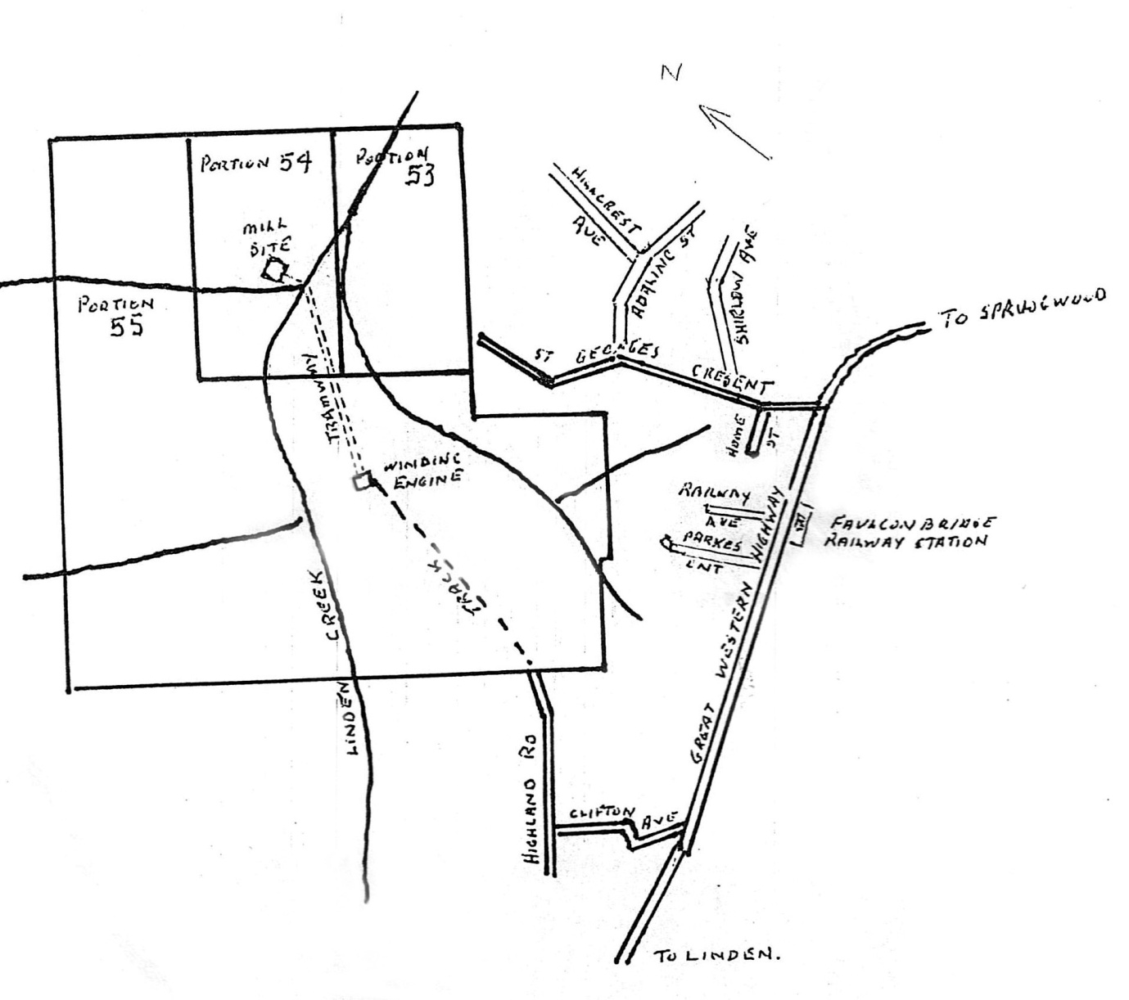

Thel 1922 photograph from the Blue Mountains Collection is the unloading of railway sleepers carried from the sawmill by horse and dray to Faulconbridge Station to be loaded into railway trucks for delivery to their final destination
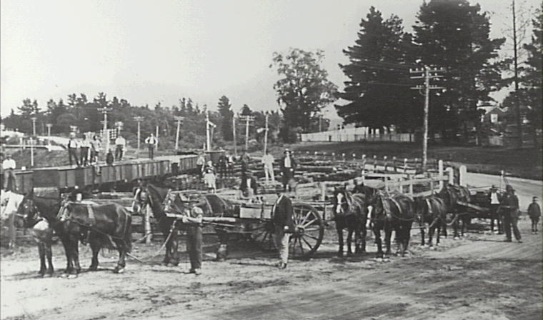

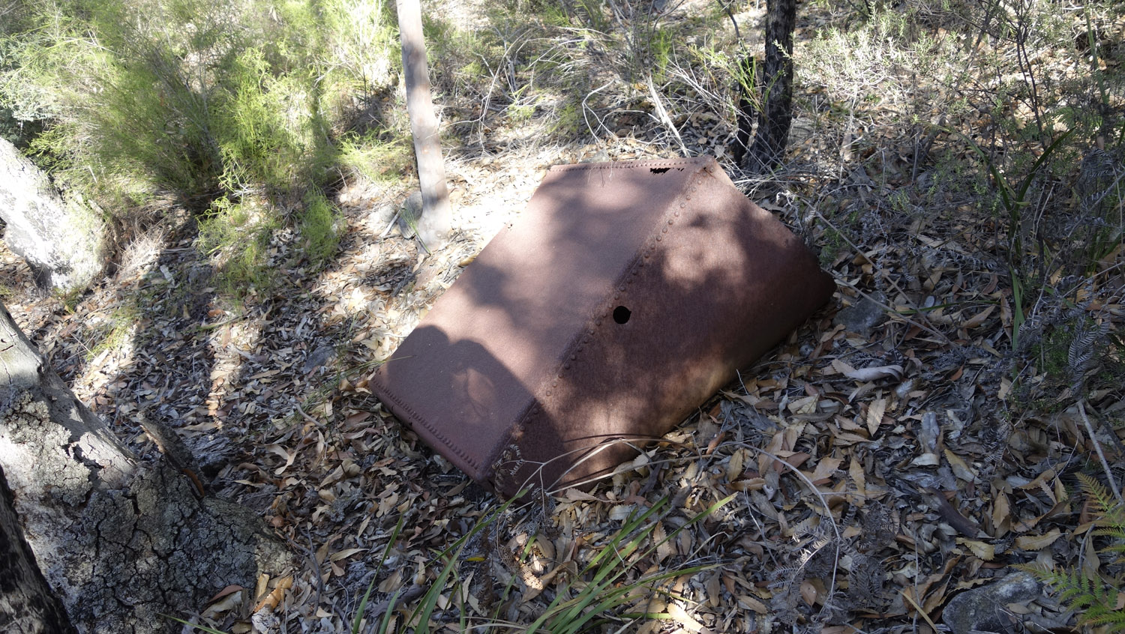

Remains of several steel tank on side of access road. Further along the track is a possible dam.

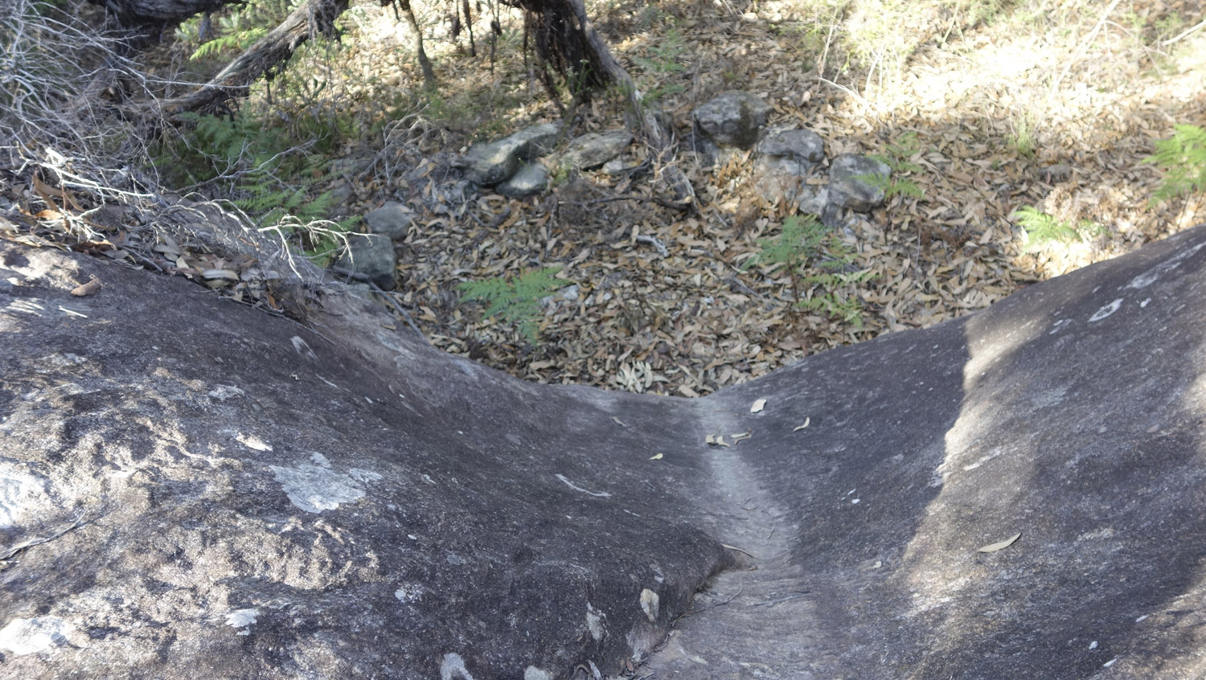

Ownership History
The question now is how successful this business was for its owners and the answer is probably it was a poor investment. There were four ownership changes over the life of the mill and as shown below there were court cases over payment problems.
Henry Joyce who obtained the land in 1909 and built the infrastructure in 1914 soon ran into financial problems with the quality and access of the timber and as suggested the high water requirement of the boiler. He became insolvent and to repay debts passed the mill on to Augustus Wilson. The date of this transfer is not known. No record on Wilson has been found.
The next owner was Charles Snell. The Springwood Historical article states that Wilson sold to Snell in 1920 for P1600.
Snell advertised on May 20, 1920 for contract timber cutters to quote for a 100 super feet price so he must have owned the mill at this time.
The Blue Mountains Echo reported on 8/10/1920 that the sawmill had changed hands for a substantial sum . The sale was handled by Messrs Molvin and Dawson. It is assumed that the vendor was Charles Snell and the purchasers were Francis James Searle, Lawrence, George Moncrieff sawmillers from Faulconbridge and John Wallace Easson of Hardwoods Ltd at Woolwich for P4000. It may have been an arrangement where Hardwoods Ltd acted as guarantee for the purchasers. There must have been cash problems as the court cases below indicate that promissory notes were not paid in time. From the newspaper reports we can find Snell had many problems getting paid.
On February 22, 1921 there was a serious fire at Hardwoods Limited yard at Woolwich which severely damaged the machinery sheds. The management stated that they would be able to supply all orders. One paper reported damage at 500 Pounds.
Percy A Wells and Co. conducted an auction on August 20 and 22nd 1921 to sell off Hardwoods Limited plant, vessels, machinery and stock. Also to be sold where six complete sawmills with bush rights all in operating order. It is assumed that the Faulconbridge sawmill was included in this sale.
On 19/9/1921 it was reported that in the District Court Charles Frederick Snell timber merchant of 20 Castlereagh Street Sydney sued Francis James Searle of Faulconbridge, Lawrence George Moncrieff of Faulconbridge sawmillers, John Wallace Easson of Woolwich merchant and Hardwoods Ltd of Woolwich for the recovery of P292/11/1 alleged to be the amount of promissory notes made by the defendants Searle and Moncrieff in favour of Charles Snell and endorsed by the defendants Easson and Hardwoods Ltd. Judgement had already been made against the defendants Searle and Moncrieff, however, Easson and Hardwoods were disputing the notice given about the dishonour. The verdict is unknown.
On December 22, 1921 Charles Patrick Snell applied for the winding up of Hardwoods Ltd in the Supreme Court. William Harrington Palmer was appointed liquidator.
On January 21 1922 Hardwoods advertised for sale poles and sleepers. Must be sold. If they were wound up in December 1921 then this may been the liquidator selling off stock.
A Sawmill plant was advertised for sale on Saturday April 1, 1922
“Complete Firewood Sawmill Plant etc, with rights to bush thickly timbered 50 miles from Sydney. Apply Watkinson Bros, George and Hay Streets Sydney.” It is assumed to be our sawmill, however, nor confirmed.
No record of a sale has been found
The following court case followed over failed payments;
Another No. 1 Jury Court case was reported by the SMH on 24/6/1922 before Justice Ferguson without a jury. The case was ‘Sale of Faulconbridge Sawmill” Snell v Easson.
C harles Frederick Snell bought the case against John Wallace Easson Managing Director of Hardwoods Ltd to recover P1088/7/0 upon a deed executed on September 15, 1920 by which the defendant covenanted to fulfil certain conditions prescribed by another deed dated September 10, 1920. It stated that the on the behalf of Snell that this September 10 deed that if a default was made by certain purchasers from Snell in carrying out their contract Hardwoods Ltd would in a certain time pay P1000 or the purchase balance of the purchase money due on the date mentioned by Snell being in possession of the Faulconbridge Sawmil together with 612 acres of land contracted to sell to Searle and Moncrieff for P4000. The contract provided that payment should be made by monthly payments of P103/6/8. On September 15 an agreement was made between Searle, Moncrieff and Hardwoods Ltd and the Snell that by which Hardwoods Ltd upon any payment default over seven days would upon notice to them would within another seven days P1000 on the purchase money or take over the benefits and liabilities of the purchasers. The payments were irregular and in the following may P108/6/8 under the deed in addition to a sum of P116/13/4. To meet these arrears a cheque for P108/6/8 was paid leaving the other amount still owing and a further agreement where the P116/16/4 and some other monies that were due to Snell by Searle and Moncrieff were secured by separate promissory notes two of which were in question in the present action. The June instalment was missed and although notice was given to Searle and Moncrieff and within the prescribed period Hardwoods Ltd and Easson the P1000 was not paid.
In his pleadings the defendant alleged the property subject to the agreement was not the plaintiff’s and he had no title to it. The plaintiff replied that he did have title and if there had been any problem Searle and Moncrieff could have rescinded the contract which they didn’t. The defendants tried to say that the promissory note issue was before the District Court and not subject to this court. The judge dismissed this argument and found for the plaintiff on the promissory notes valued at P88/7/6 each with P4/0/0 interest. He found the notice of default on the June payment did not reach Hardwoods Ltd as set out in the agreement and entered a verdict for the defendant on the P1000 claim.
As can be seen from these court cases that the purchasers had financial problems .
The Springwood Historical article states that for a short time the top engine was used to cut firewood timber for a Katoomba fuel merchant. It is not known when the valley operations cease and some of the equipment removed leaving the boiler which would be too heavy to raise up the incline. Also no dates are known when the top machinery was removed.
The land was resumed in 1928 and placed in the Faulconbridge Park which was later The Blue Mountains National Park.
Footnote.

When thinking about this sawmill site several questions stand out and unless any more information can be found probably will remain unanswered.
The Top Winding Engine.
Steam winding engines were very specialised and designed to do the specific task of lowering and raising a load down a pit or incline. From the photograph below it can be seen that there are four
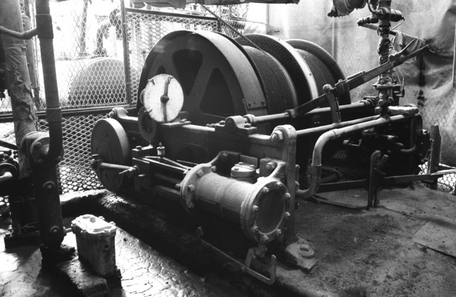
Small Steam Winding Engine
main parts to a winding engine.
* The steam engine and geared drive to the main cable drum. The engine should have reversing gear if the engine is required to drive in both directions. Winder plants were fitted with two cylinders set a quarter apart as a single cylinder engine would have two dead spots and if the engine stopped on a TDC or BDC dead spot it is difficult to get it started again
* The cable drum which in our case needed to hold over 900 metres of 1.5 inch diameter cable.
* The snap brake and lever assembly to control the cable drum rotation.
* The dial indicator showing how far the load has travelled. The engine operator has to know where his load is at any time so he can stop when it reaches its end of travel. In this case that was over 900 metres away down a steep slope so the operator would not have any visual indication where his load was on a descent. If there wasn’t an indicator system then the operator would use marks on the rope to judge when to stop. This would be prone to error and possible accidents
. A steam engine needs a boiler and there is no indication at the top section of a boiler or any building remains apart from some stone foundations which are to small for a winder. Then there is the question of water supply to feed a boiler which is lacking at this site. Some winders were portable and could be weighed down.
There were single or double drum designs operated by clutches The drum(s) were loose on the drive shaft .Generally there would be spur gearing in the drive system. The best braking was to have the load work against the steam pressure while the simplest was to have a strap brake on a flywheel which isn’t ideal as there was a danger of loss of control and possibility of stripping the gear train..
.

